

The Leinster School of Music and Drama

Certificate of Proficiency in Teaching

100 marks

June 2011

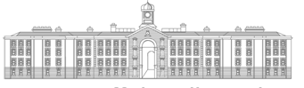
GRIFFTH COLLEGE DUBLIN

All three parts to be answered

Part 1. Rudiments (40 marks)

Answer five of the 6 sections in this section

- Rewrite the following extract as it would be played

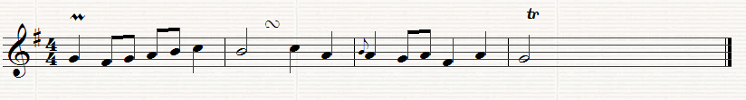

- Transpose this short extract up a minor 3rd.

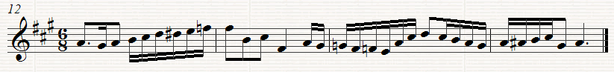

- Identify the following intervals

_________________________________________________________

- Describe fully each of these triads and state whether they are in root position, 1st or 2nd. Inversion

_______________________________________________________________

- Insert the time signature and add bar lines to the following extract.

- Explain four of the following terms

(a) Pesante (d) Stringendo

(b) Accelerando (e) Cantando

(c) Senza Rall (f) Attaca

Part ii Analysis (30 Marks)

A (For Piano candidates)

Study this 2nd movement from Haydn’s Sonata in G Hob XVI/G1 and answer all the questions below

- With reference to bar numbers outline the structure of this movement, including modulations.

- Outline the difference between a minuet and a scherzo

- Describe the chords including position in bars 13 and 14

- Identify the cadence between bars 37 and 38

- Identify the Key in Bars 31 and 32

Part iii History (30 Marks)

Answer A or B. Include musical citations or examples to support or answer

A (1685 – 1800)

One question only to be answered

A1 Compare and contrast the oratorios of Bach and Handel

Or

A2 Outline to development of the orchestra in the time of Haydn and Mozart

B (1800 – 1900)

One question only to be answered

B1 Assess the contribution of Beethoven to the development of the symphony

Or

B2 Discus the development of Lieder under Schubert

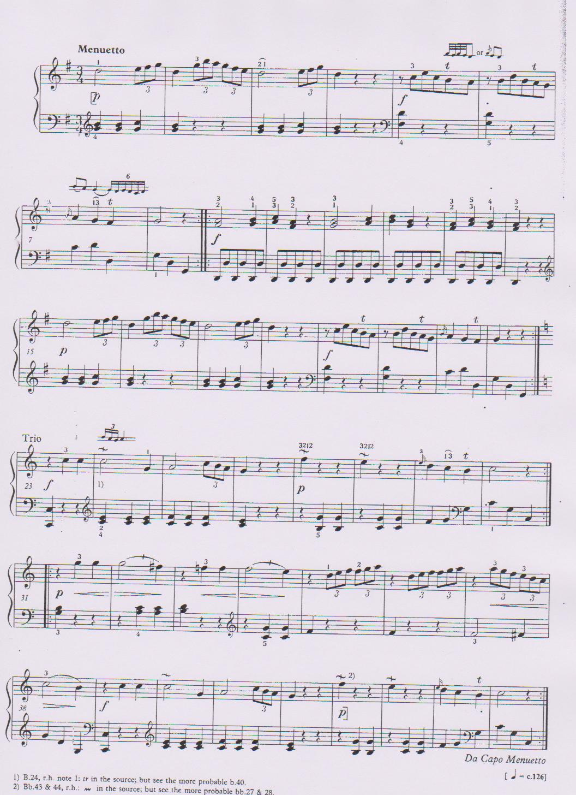

The Leinster School of Music and Drama

Professional Diploma for Teachers

Paper 2: 100 marks

June 2011

GRIFFTH COLLEGE DUBLIN

All three parts to be answered

Part 1: Teaching methods (40 marks)

Answer one question from section A and one from section B

Section A

A1 Outline how you would explain the difference between simple and compound time to a student. Use musical examples to support your answer

Or

A2 Aural training is an essential element in a student’s development. Outline the steps you would take to improve this facility

Section B

B1 Name two pieces for piano which would develop a cantabile touch and discuss how you would instruct a student to improve this technique

Or

B2 Explain the function of the sustaining pedal and how you would demonstrate this to a student

Part 11: History (30 marks)

Candidates should answer two questions only in this section – both questions must be from the same chosen historic period. Include musical citations and/or examples where relevant to support you answer

1685 – 1800

- Discuss the features of the Suites of either Bach or Handel

- Assess the importance of Mozart as a composer of Opera

- Compare and contrast the symphonic styles of Mozart and Haydn

1800 – 1900

- Who would you class as the composer who most contributed to writing for the piano in the 19th. Century. Assess the composers importance with reference to relevant compositions.

- “As a composer of song, Schubert stands supreme.” Discuss

- Outline the further development of the Symphony after the death of Beethoven

1900 – 1999

- The 20th century produced a number of eminent Irish Composers. Name three and discuss in some detail the work of one of them

- Outline the features of Impressionism with special reference to the Music of Debussy and Ravel.

- Discuss the diverse rhythms and dissonant techniques in the music of Stravinsky and Bartok

Part iii: Analysis (30 marks)

Study the attached copy of Mozart’s Sonata in F, K. 332, 1st. movement and answer the following questions.

(i) Using bar numbers outline the form of the movement, including the principal key changes

- Describe the chords (including position) n bars 98 – 104.

- What key is suggested in bars 57 – 58

- Identify the cadence and key between bars 74 and75, 104 – 105

- Give the meaning of each of the following:-

Allegro
Cresc
sf
tr
sfp

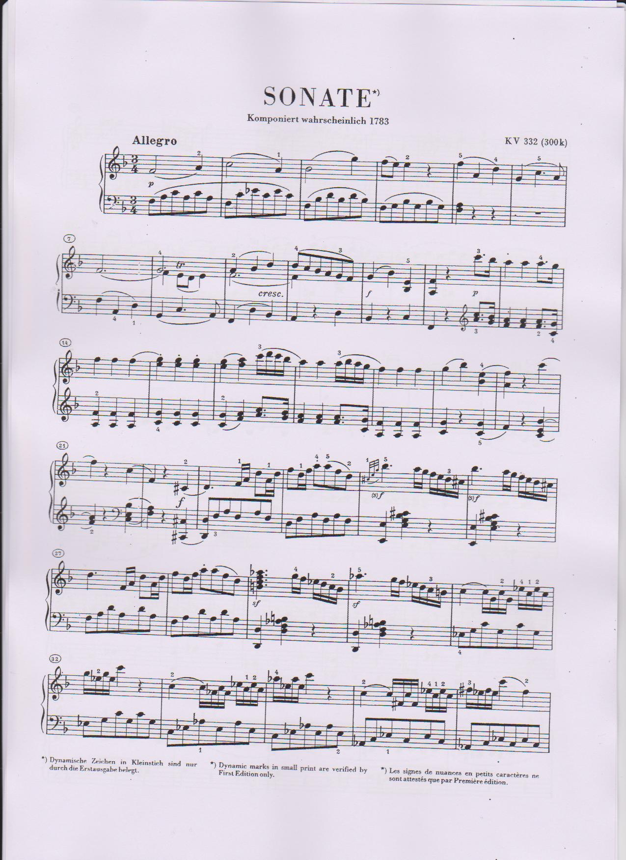

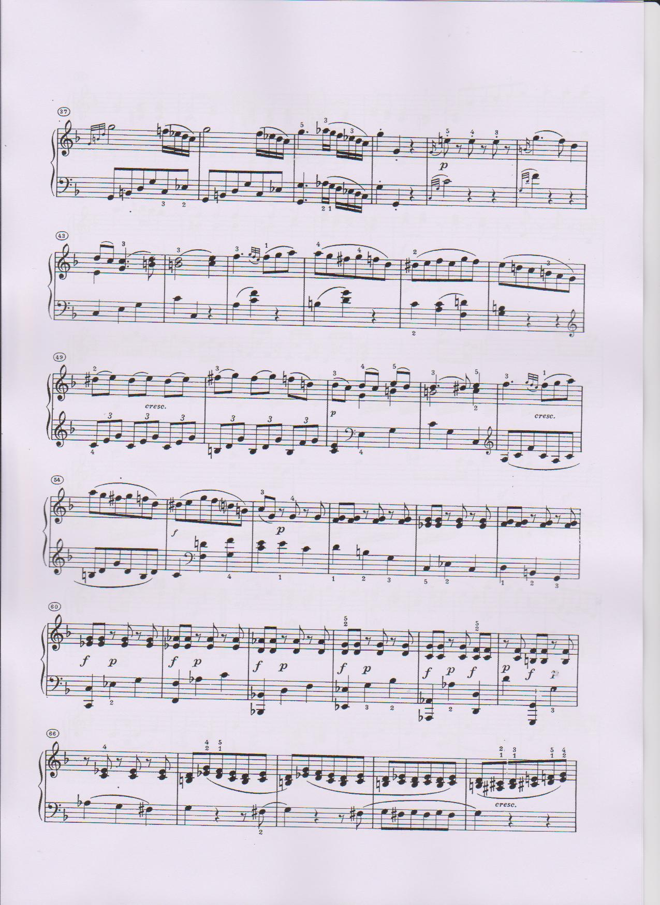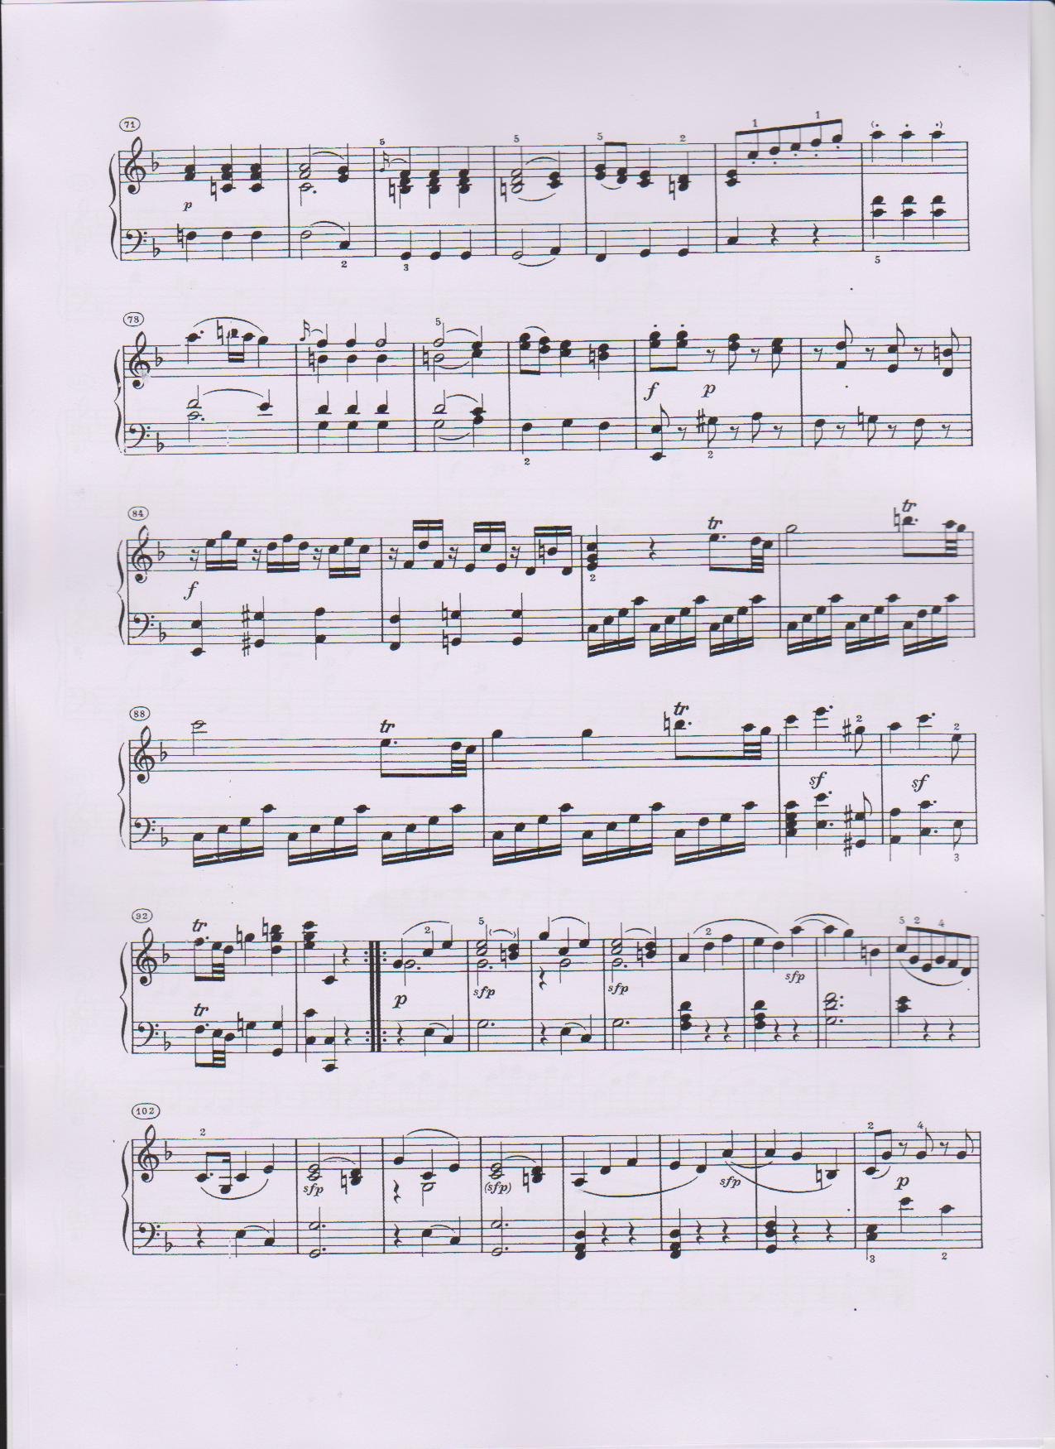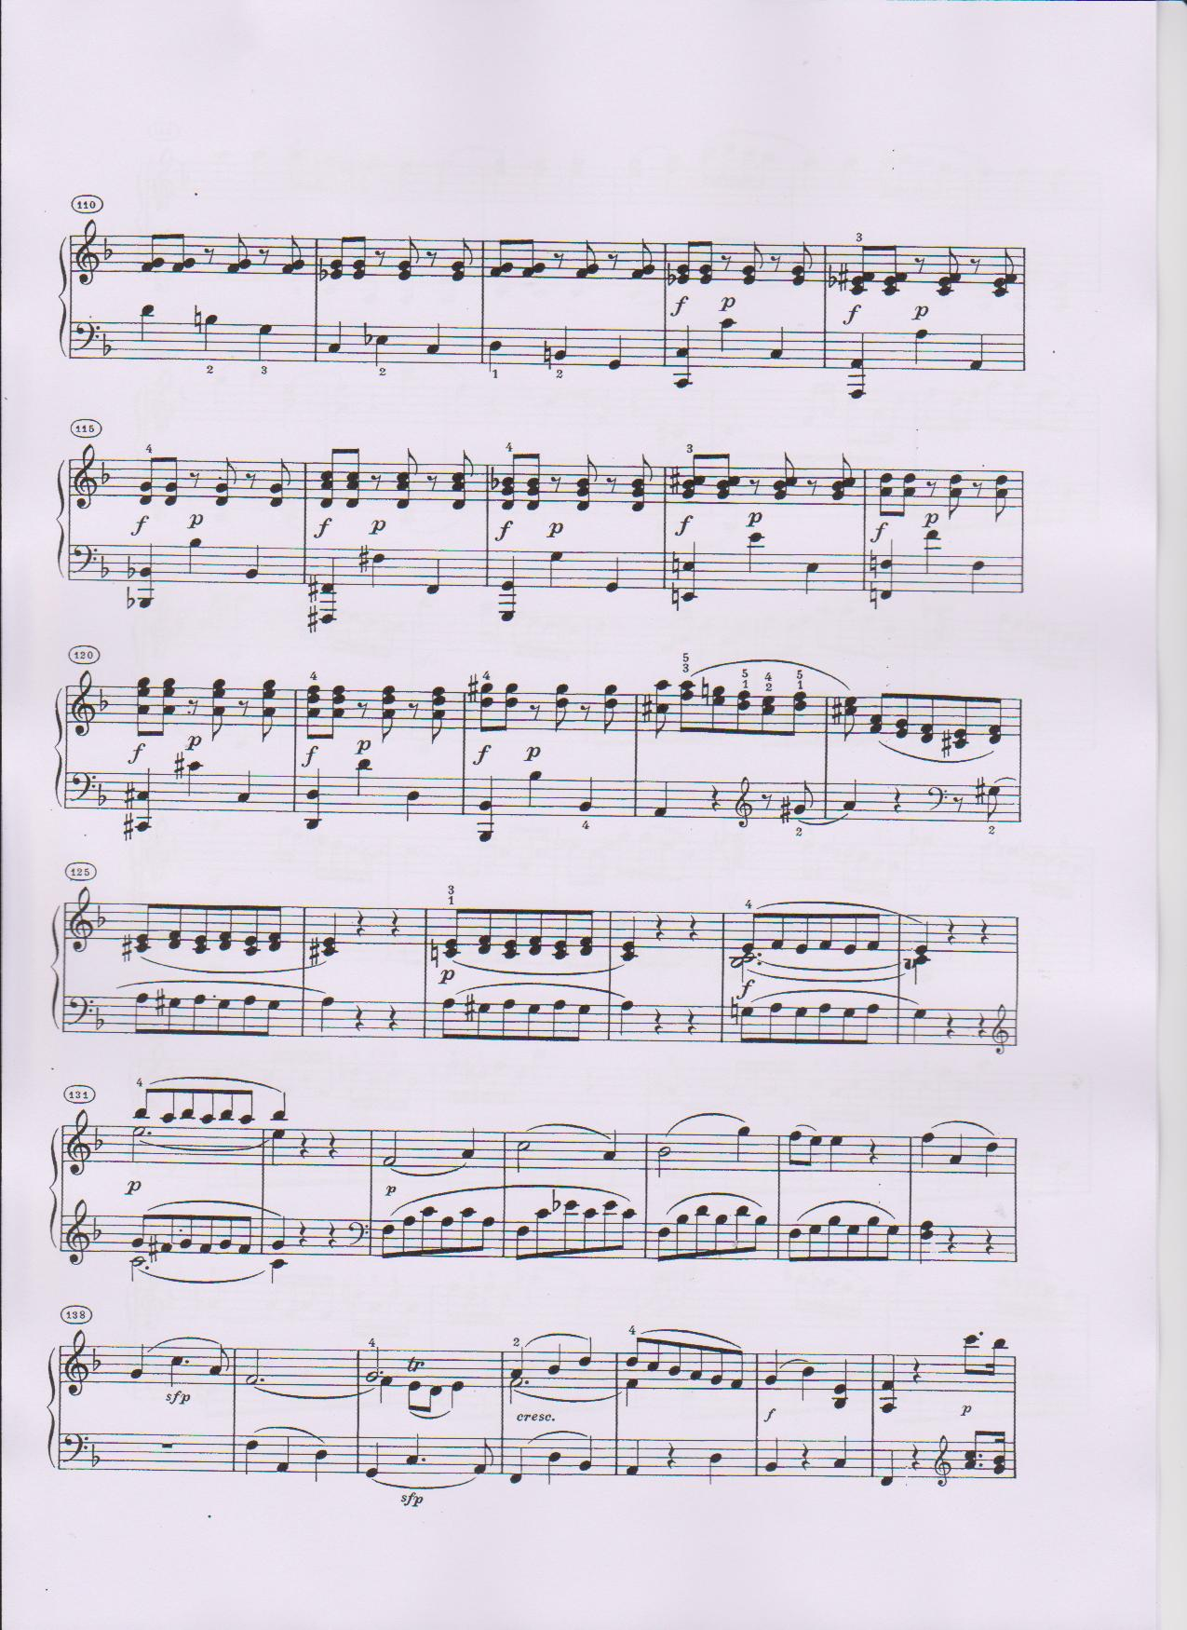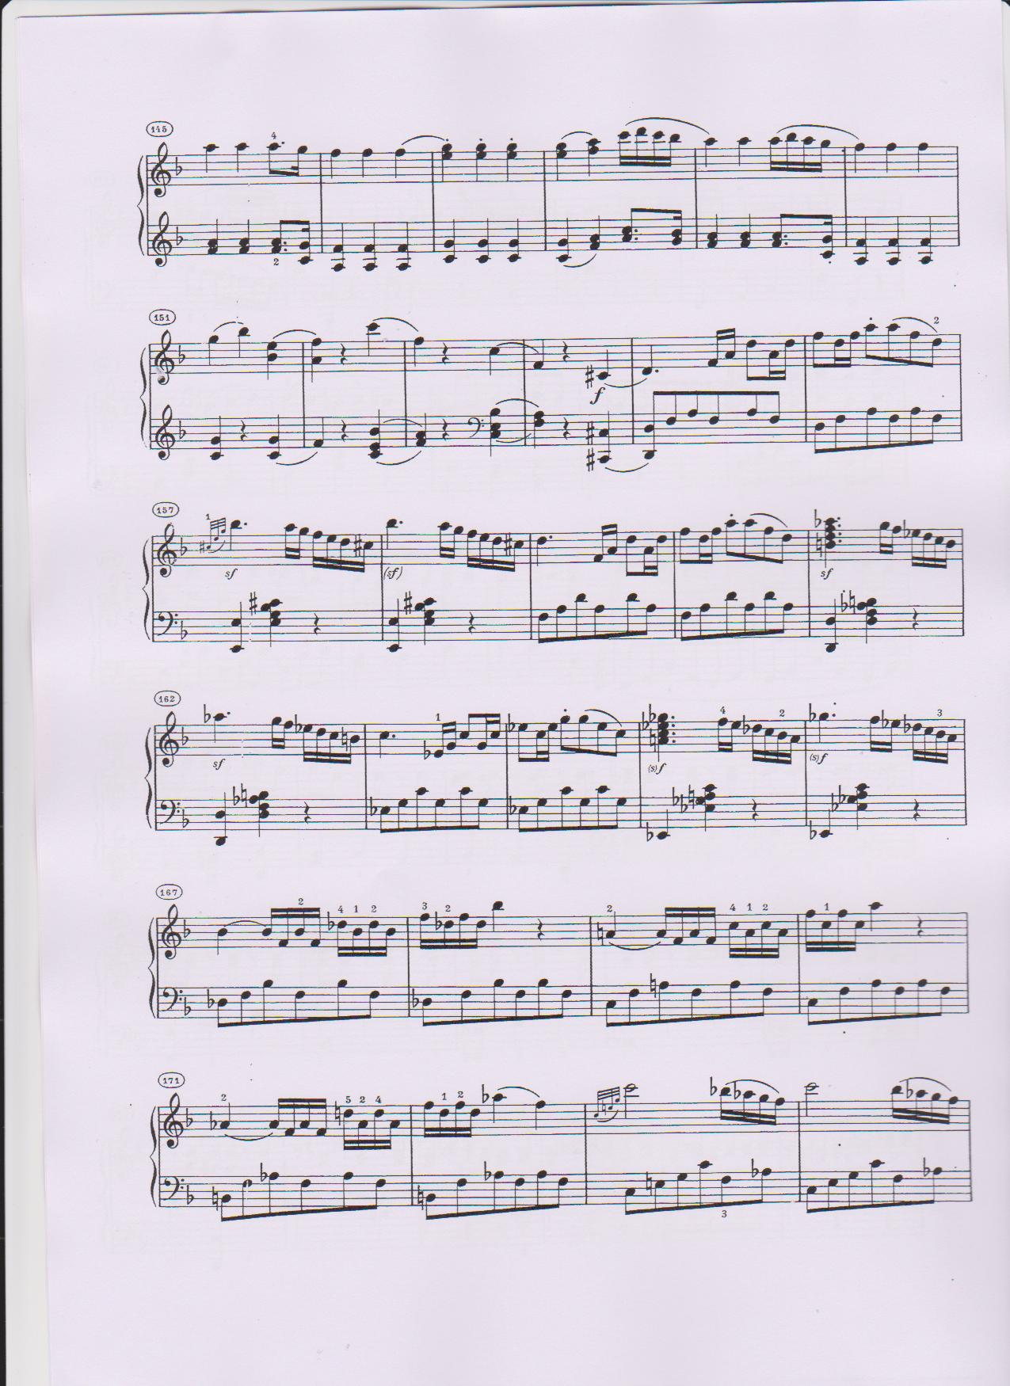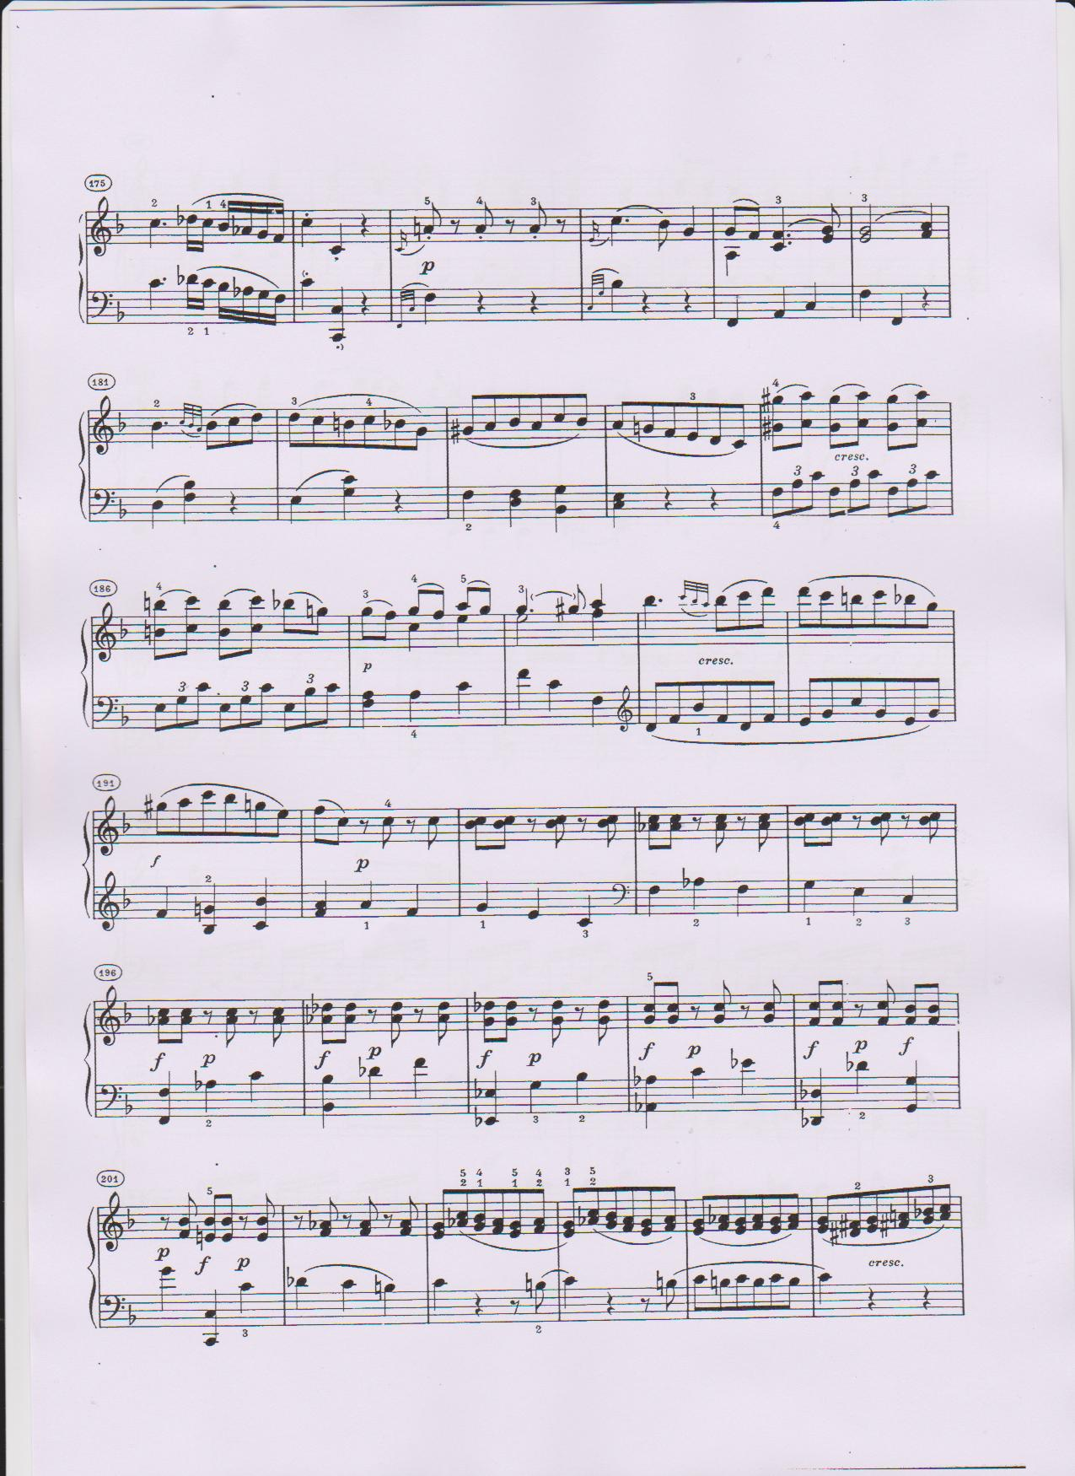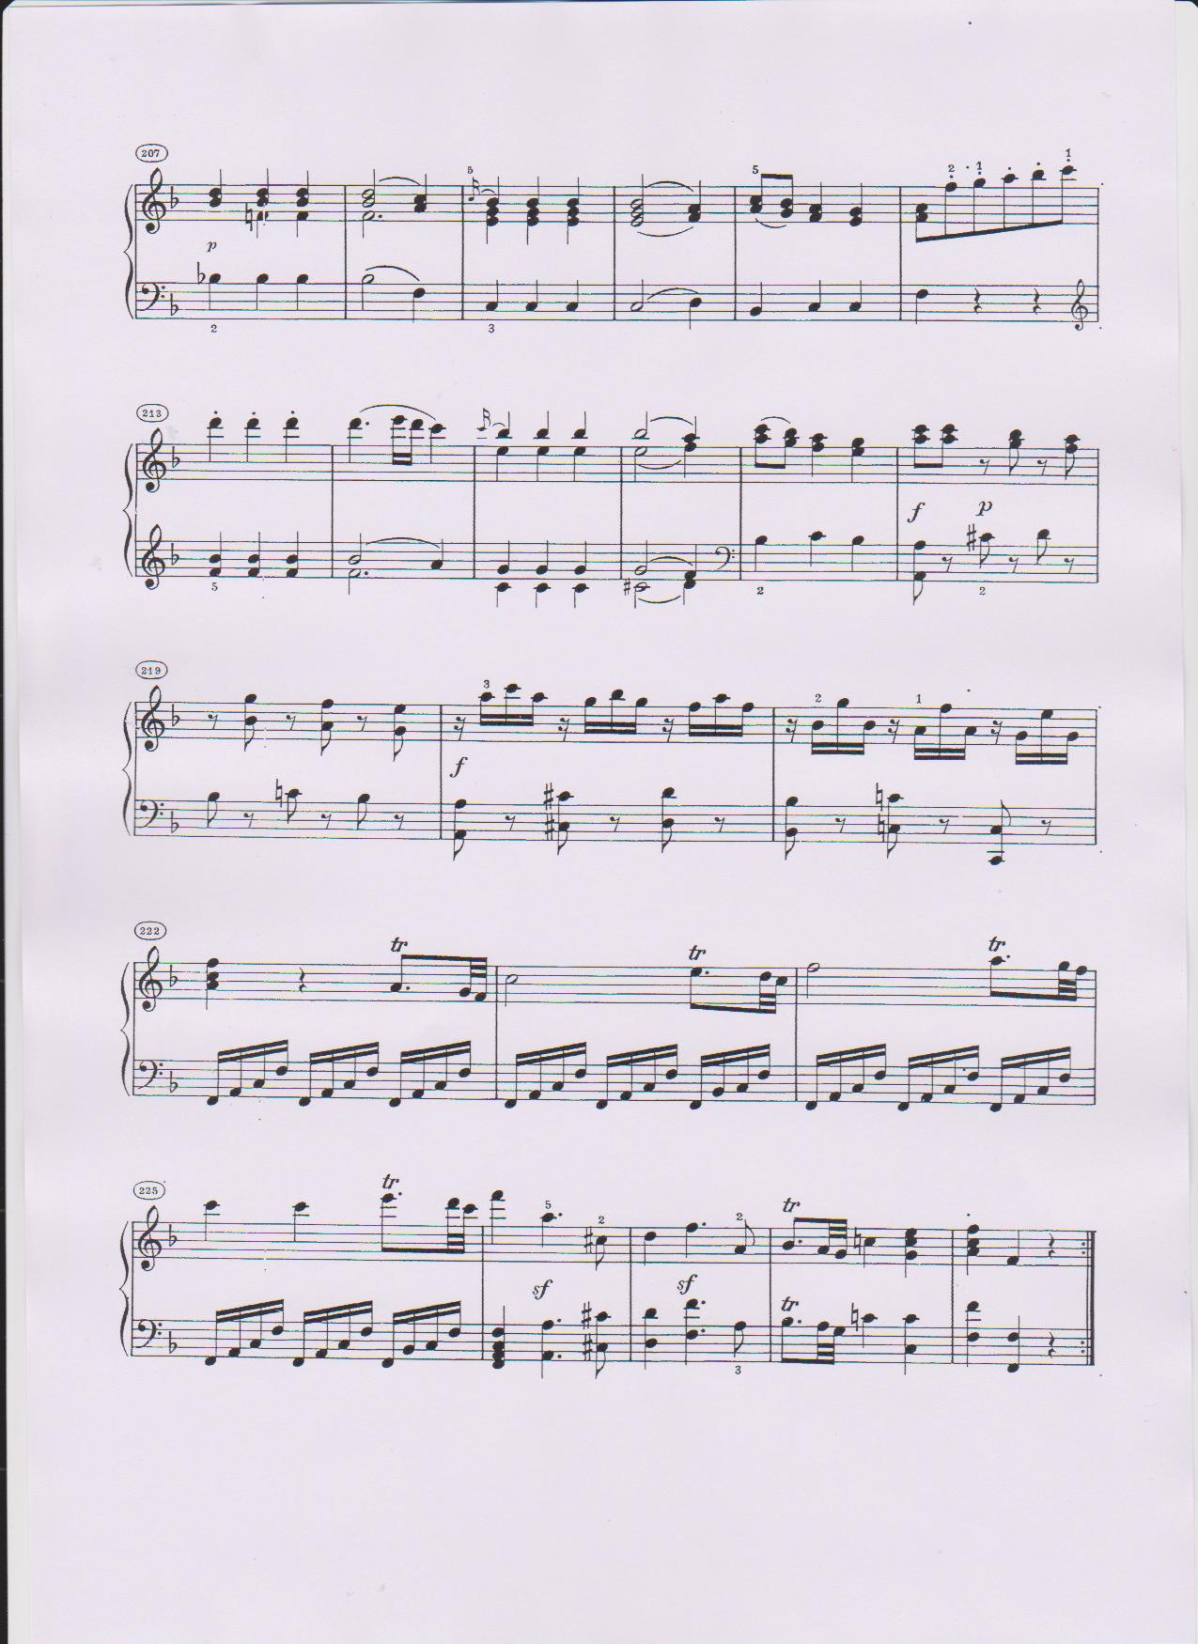

The Leinster School of Music and Drama

Professional Diploma for Teachers

Paper 1: 100 marks

June 2011

GRIFFTH COLLEGE DUBLIN

All three parts to be answered

Part 1:-Aural Training and General Musicianship (30 Marks)

All Three sections in this section to be answered

- Transpose the following excerpt up a Diminished 5th and insert the new key signature

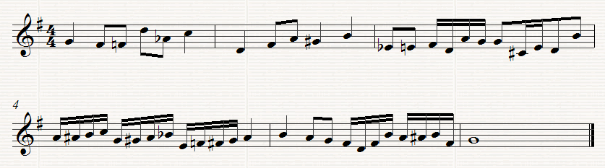

- Answer (a) or (b)

- Identify the following Intervals

______ ______ ______ ______ ______
Or

- Above the following notes write the following triads

Diminished 1st. Augmented Minor 2nd. Major 2nd Diminished 2nd
Inversion Root position Inversion Inversion Inversion

- Rewrite the following as it would be played

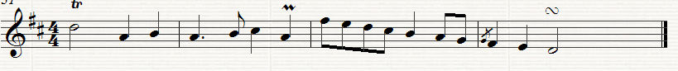

Part ii: Harmony (4o marks)

One question only to be answered in this section

- Harmonise the following extract by adding parts for Soprano, Alto and Tenor

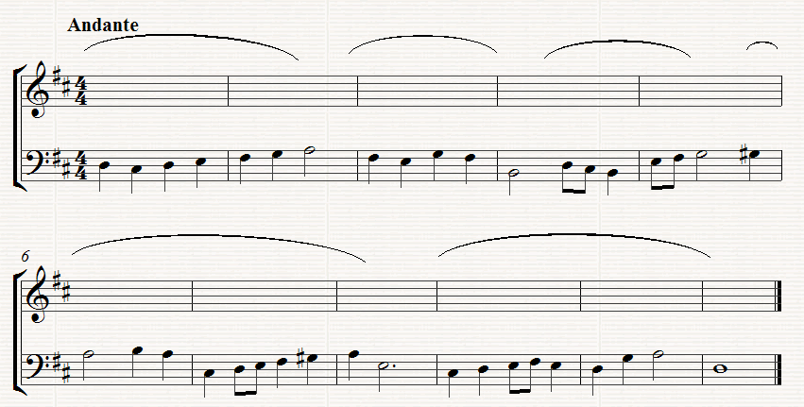

Or

2, Complete the following extract

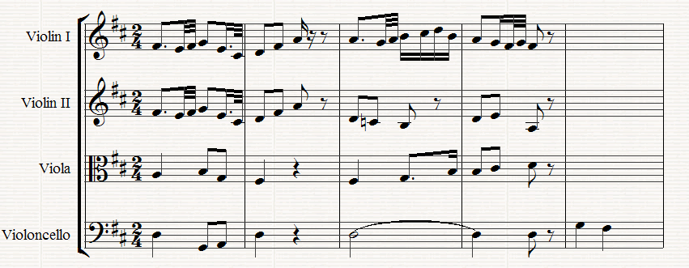

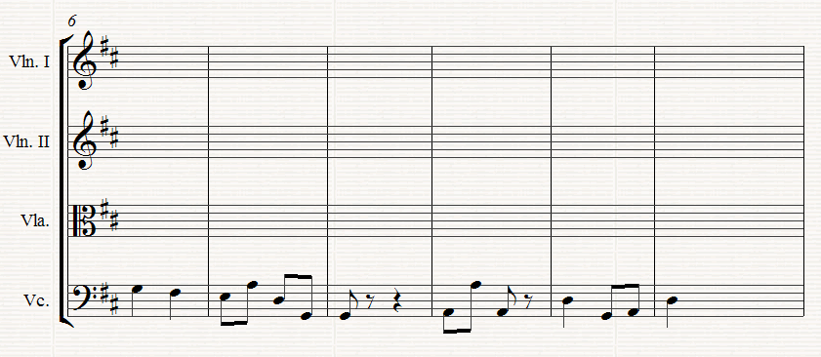

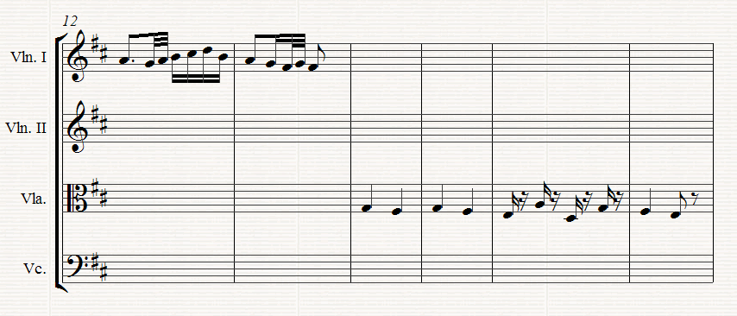

Part iii:- Contrapuntal Harmony (30 Marks)

One question only to be answered in this section

- Complete the following by adding a part for Bass voice

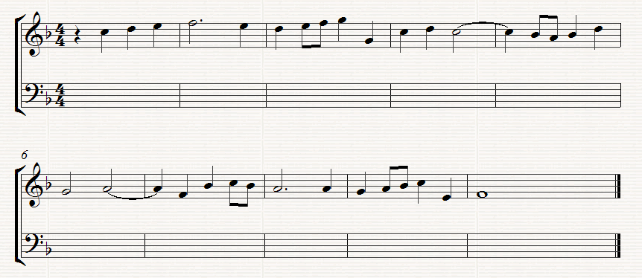

Or

- Complete the following extract by adding an upper part.

