

Leinster School of Music and Drama

Theory Examination Paper

Grade 6

Summer 2011

Name:- ________________________________

Total Marks 100

All questions should be attempted.
Please write your answers in this booklet

Duration:- 3 hours

Question 1 (15 Marks)

Answer either (a) or (b)

- Indicate suitable chords to accompany the following melody. You may write Roman numerals or any other recognized method of notation below the staves or by writing notes on the staves, but use only one of these methods.

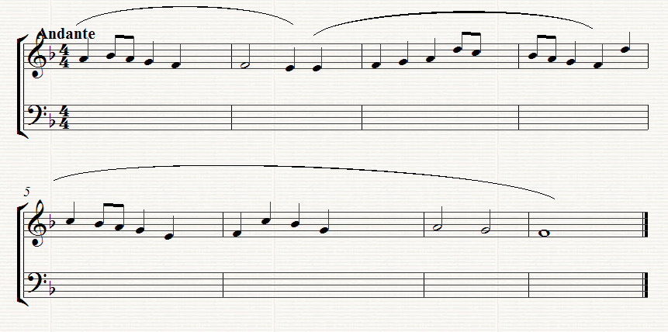
- Complete the figured Bass part in the following extract:-

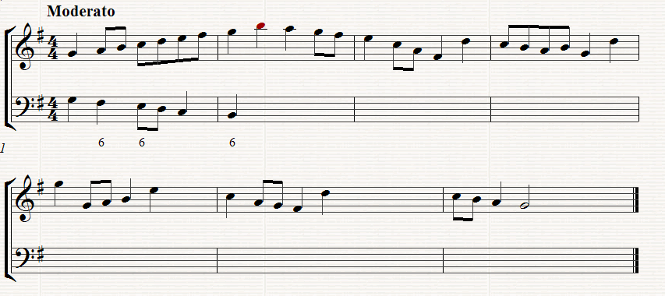

Question 2 (15 Marks)

Write for four Voices (SATB) or keyboard, realize this figured Bass. Assume that all chords are 5/3 unless otherwise shown.

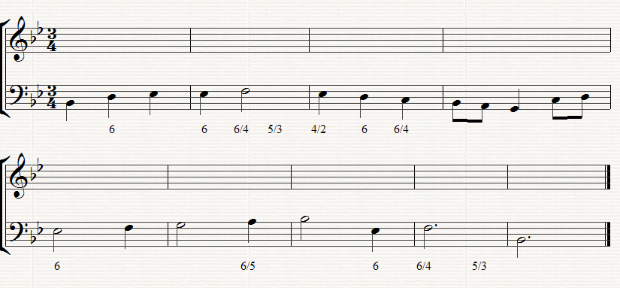

Question 3 (20 Marks)

Answer either (a) or (b)

- Continue this opening to form a melody for unaccompanied clarinet. It should end wit a modulation to the dominant key. The complete melody should be 8 to 10 bars long. Ann performance directions as appropriate.

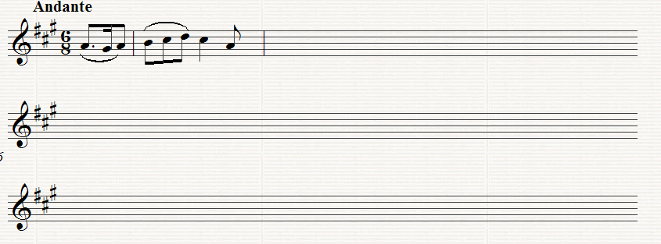

OR

- Continue this opening for unaccompanied Violin to make a complete piece of not less that 8 bars. You should modulate to the key of the dominant. Add performance directions as appropriate.

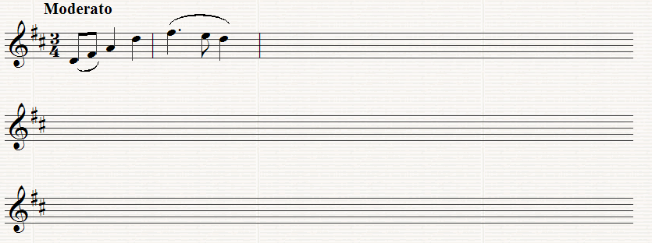

Question 4 (25 Marks)

Study the following extract from Handel’s Judas Maccabeus with the orchestral part reduced for piano, and then answer the following questions.

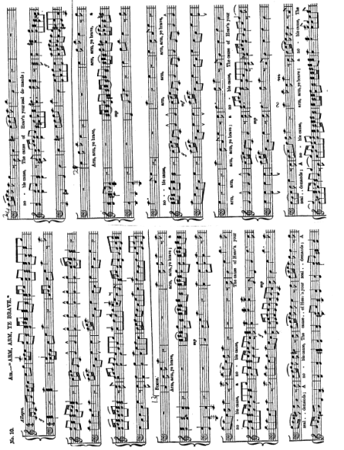

- Mark clearly on the score, using the appropriate capital letters for identification, one example of each of the following

- In the Introduction (bars 1 – 12)

A A Dominant 7th Chord in root position
B A Chord of the Tonic in First Inversion
C A Perfect Cadence
(ii) In the vocal Part,
D A bar outlining the Tonic Chord

(b) Write out the vocal part of the second last bar from the end as it would be performed

- Write out the four bars at the end of the first page as they would be written for the B flat clarinet

- Draw a circle round the notes in notes in the accompaniment of Bar 15 which are not part of the Harmony. What is the name given to these notes?

_________________________________________

- Name two similarities and two differences between 13 – 15 and Bars 29 – 31

Similarities _______________________________________________

_________________________________________________________
Differences ______________________________________________

_______________________________________________________

Question 5

Study the following Orchestral extract from Beethoven’s 5th Symphony and then answer the following questions:-

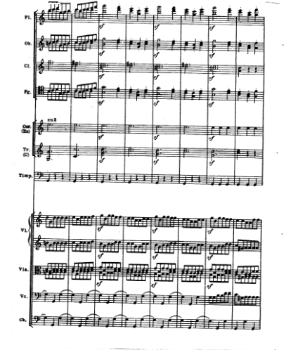

(a) (i) Explain what u2 for the Horns in the first bar means? _________
(ii) Name two Brass Instruments which are not included in this extract___________________________________________
  - Name one Wood wind and one percussion Instrument which are not included in this extract

(iv) Which String Instrument uses double stopping here ____________

- Write true or false after each of the following statements:-

(i) The Flutes have an accompanying role only ______________
(ii) the Oboe plays legato throughout ___________________

- Write out the clarinet parts as they would sound:-

- Mark each of the following clearly on the score, using the appropriate capital letter for identification :-

A A double stop of a minor 6th. In the string part
B An Interval of a compound Perfect 5th between the ‘Cello and the violin
C The interval of a minor 6th. Between 2 Wood wind Instruments

