

Leinster School of Music and Drama

Theory Examination Paper

Preparatory Grade

Summer 2011

Name:- ________________________________

Total Marks 100

All questions should be attempted.
Please write your answers in this booklet

Duration:- 1 hour

Question 1 (10 Marks)

Write the letter names of each of the following notes in the space provided

_____ _____ _____ _____ _____

Question 2 (10 Marks)

Write the following notes as Crotchets (Quarter notes)

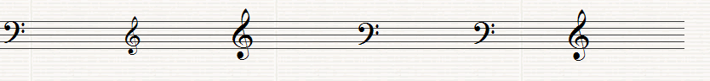
G on a line C in a space B on a line E in a space A on a line F on a line

Question 3 (10 Marks)

Insert the correct Clef before each of these notes to make the letter name fit

B C A A F

Question 4 (20 Marks)

Write the letter name and value time each note below each the following. (i.e. C, 1 beat)

Letter ______ _______ _______ _______ _______

Time _______ ______ _______ _______ _______

Question 5 (10 Marks)

Fill in the missing Time Signatures before each of the following extracts

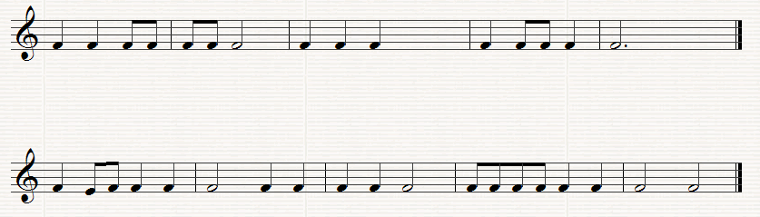

Question 6. (10 Marks)

Put one note only at each Asterix to make the time signature correct

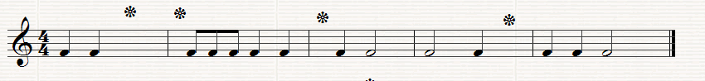

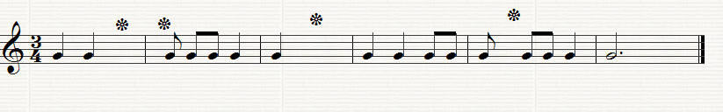

Question 7.
Answer the Questions on the following Piece of Music. All of the answers are found in the extract.

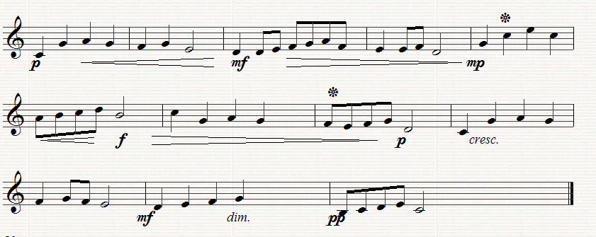

(a) (10 Marks)
Put in the correct time signature at the start of the extract
How many bars are there in the piece? ___________________________
What type of clef is used? _____________________________________
Which is the loudest bar in the piece? ____________________________
Which is the softest bar in the piece? ____________________________

(b) (10 Marks)
What does f mean? _________________________________________
What does mp mean__________________________________________
What does cres mean ____________________________________
Name the note marked * in Bar 5 _____________________________
What is the value of the note marked * in Bar 8 __________________

(c) (10 Marks)
Copy out the last four bars in the clef, time-signature and any directions given.

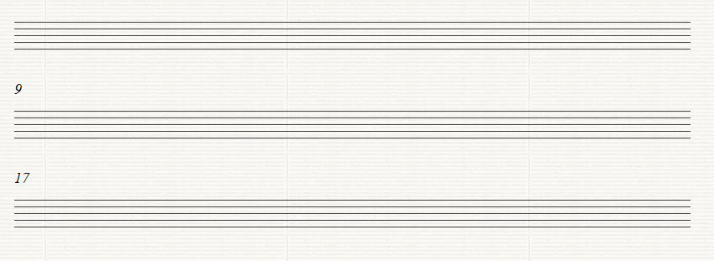

Leinster School of Music and Drama

Theory Examination Paper

Grade 1

Summer 2011

Name:- ________________________________

Total Marks 100

All questions should be attempted.
Please write your answers in this booklet

Duration:- 1 hour and 30 minutes

Question 1. (10 marks)

(a) Write the letter names of each of the following notes in the space provided

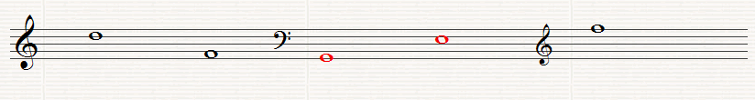
______ ______ ______ ______ ______

(b) write the following notes as Minims (Half notes)

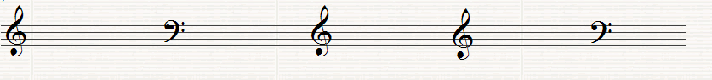

F in a space F on a line A in a space B on a line G on a line

Question 2. (10 Marks)
Write the letter names (including sharp, flat or natural) and the time value of each of the following notes (i,e. C#, quaver)

Letter ___ _____ ______ _____ _____

Type_____ ____ ______ _____ _____

Question 3. (10 Marks)
(a) Fill in the missing Time Signature before each of the following extracts

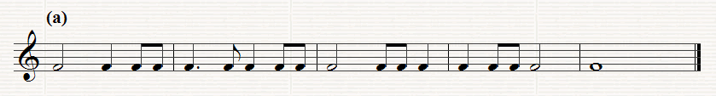

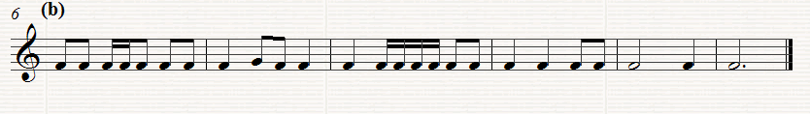

(b) Put one note only at each asterix to make the time-signature correct

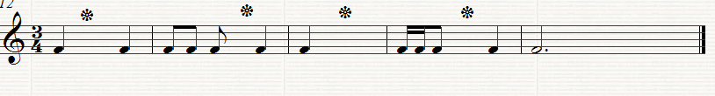

(c) Put one rest only at each asterix to the make the time signature correct

Question 4. (10 Marks)

- Re-write this extract grouping the notes correctly according to the time signature

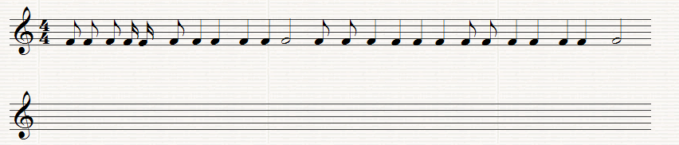

(b) Add the missing Bar lines to the following extract

(c) Add two more bars to this opening rhythm

Question5. (10 Marks)
(a) Write the scale of D major, descending without Key-signature, in the given Clef in minims (half notes). Mark the semi-tones with a slur.

(b) Write the scale of F major ascending with key signature, in the given Clef in crotchets (quarter notes). . Mark the semi-tones with a slur

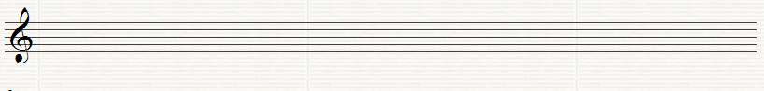

Question 6. (10 Marks)
(a) Write the tonic triads of the following keys using key-signatures

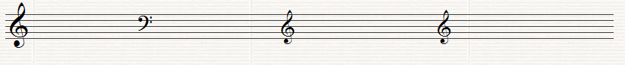

G major F major D major C major

(b) Name the Intervals (by number only) using the bottom note as the tonic (key note)

______ ______ ____ _____ _____

Question7. (10 marks)
Name the degrees of the Scale of the following notes, all taken from the Key of D major

_____ _____ ____ _____ _____

Question 8.
Answer the questions on the following Piece of Music. All answers can be found in the extract

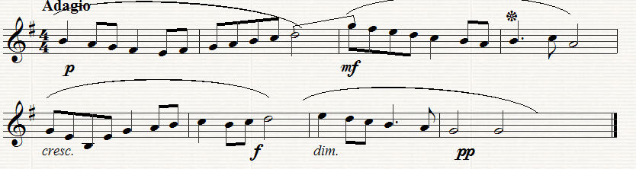

(a) (10 Marks)
What is the Key of the extract?_______________________________
What does Adagio mean?_____________________________________
How many bars are there in the extract? __________________________
What are the long curved lines over the notes known as? _____________
Which degree of the scale does Bar 6 begin on? ____________________
(b) (10 Marks)
Which bar is the loudest? __________________________________
What does mf mean? ________________________________________
What does cresc mean?___________________________________
How many beats does the note in Bar 4 marked*get?__________________
What is the interval (by number only) between the last note in Bar 2 and
the first note in Bar 3 ______________________________________

(c) (10 Marks)
Copy out the melody from Bar 5 to the end inserting the clef, key-signature, time-signature and any directions needed. Marks will be awarded for neatness and accuracy.
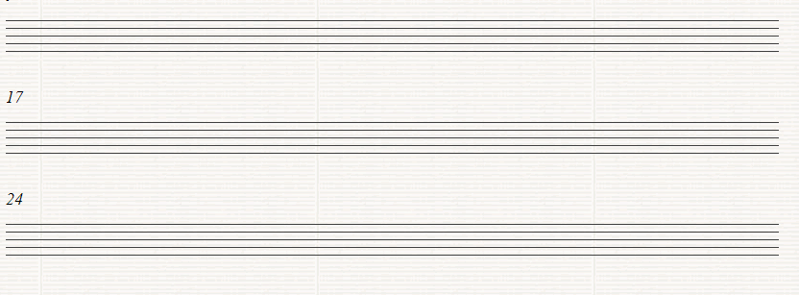

Leinster School of Music and Drama

Theory Examination Paper

Grade 2

Summer 2011

Name:- ________________________________

Total Marks 100

All questions should be attempted.
Please write your answers in this booklet

Duration:- 1 hour and 30 minutes

Question 1. (10 Marks)
(a) Write the letter names of each of the following notes in the space provided

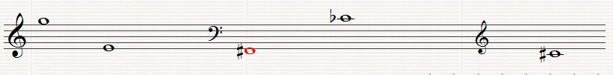
_____ _____ _____ _____ _____

(b) Write the following notes as Crotchets (Quarter notes)

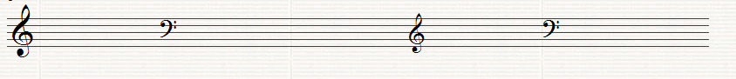
A in a space G on a line C in a space E on a line D on a line

Question 2. (10 Marks)
(a) Write the equivalent rests beside the following notes

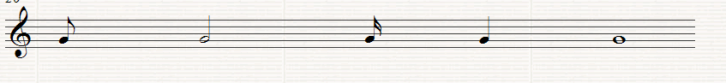

(b) Fill in the missing Time Signature before each of the following extracts

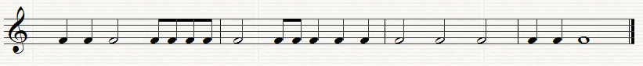

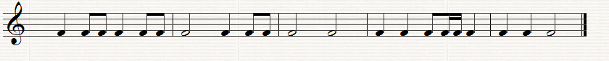

Question3. (10 Marks)
(a) Insert one note only at each asterix to make the time-signature correct

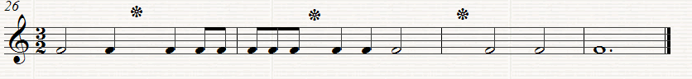

- Put one rest only at each asterix to make the time signature correct
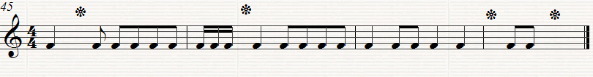

Question 4. (10 Marks)

(a) Re-write this extract grouping the notes correctly according to the time-signature

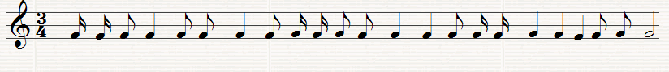

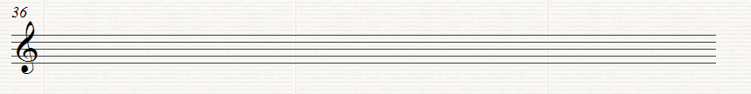

(b) Add the missing bar lines to the following extract

Question 5. (10 Marks)
Use the given opening to make a four-bar rhythm. Use a triplet figure in your answer.

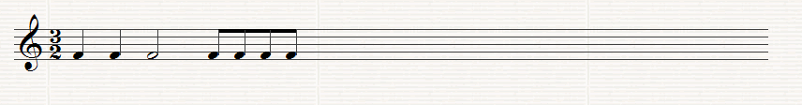

Question 6. (10 Marks)

(a) Write the Scale of D minor (Harmonic or Melodic form) ascending with key-signature. Use crotchets and mark the semi-tones with slurs.

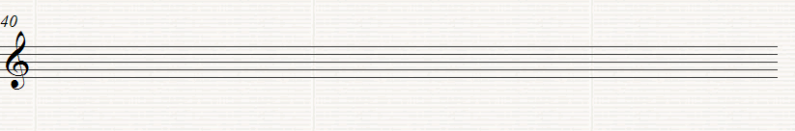

(b) Write the scale of B flat major, descending without key-signature. Insert any necessary accidentals. Use minims and mark the semi tones with slurs.

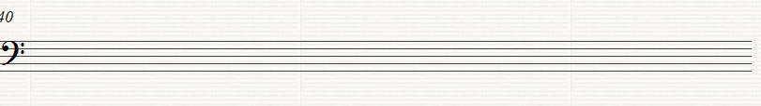

Question 7. (10 Marks)

(a) Write the tonic triads of the following keys without using key-signatures, but adding any necessary accidentals

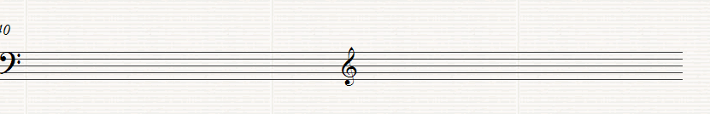
E flat major D minor

(b) Name these Intervals (by number only) using the bottom note as the tonic (key note)

_____ _____ _____ _____

(c) Name the degrees of the scale of the following notes, all taken from the scale of F major

_____ _____ _____ _____ _____

Question 8.

Answer the Questions on the following piece of music. All the answers can be found in the extract.

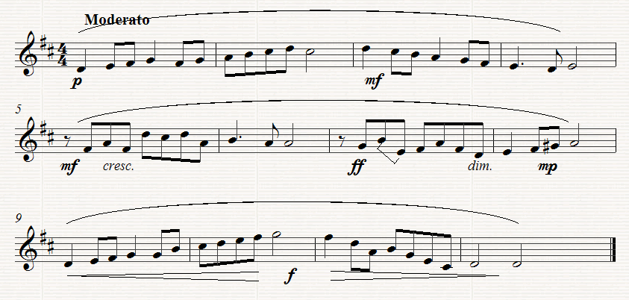

(a) (10 Marks)
(i) What key does the extract begin in? __________________
(ii) What key does the extract change to in Bar 8 ____________
(iii) What is the Interval between the second two notes in Bar 7 ____
(iv) What is the letter name of the highest note ______________
(v) What is the letter name of the lowest note? _______________
(b) (10 Marks)
(i) What does Moderato mean?_________________________ (ii) What does cresc mean? ______________________________
(iii) What kind of rest is used in Bar 5 ___________________
(iv) How many phrases are there in the extract? ________________
(v) Describe what directions are given between bars 9 to 12 ____________________________________________________
(c) (10 Marks)
Copy out from Bar 7 to the end of the extract. Insert the Clef, time-signature, key signature and any other directions needed. Marks will be awarded for neatness.

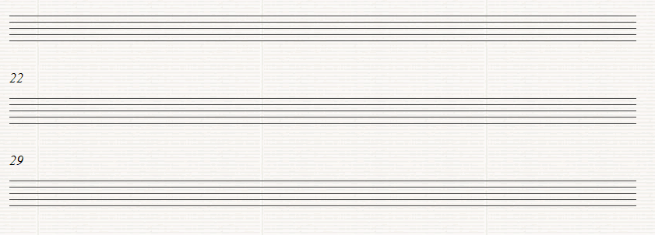

Leinster School of Music and Drama

Theory Examination Paper

Grade 3

Summer 2011

Name:- ________________________________

Total Marks 100

All questions should be attempted.
Please write your answers in this booklet

Duration:- 2 Hours

Question 1 (10 marks)

Add the missing bar-lines to each of the following extracts which all begin on the first beat of the bar

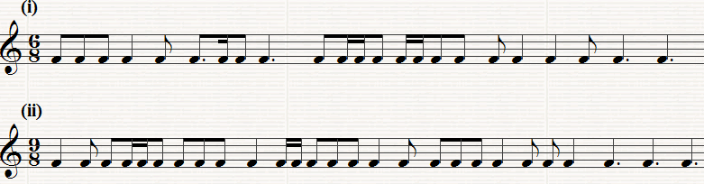

Question 2. (10 Marks)

Write a four bar rhythm in 12/8 time using the given opening which begins on an up beat.

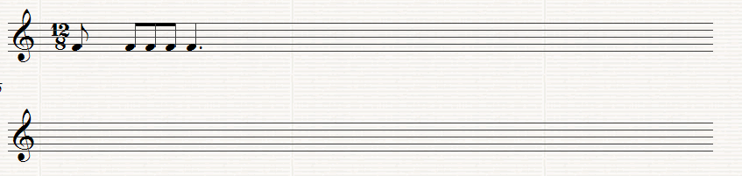

Question 3. (10 Marks)

Rewrite the following with the notes grouped correctly. Add rests to complete the final bar

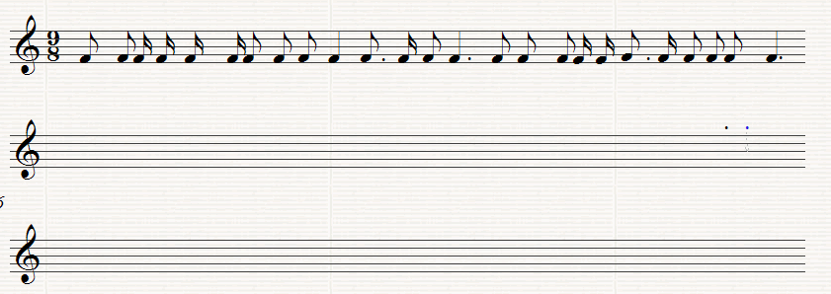

Question 4. (10 Marks)
Write the following scales using the given rhythm

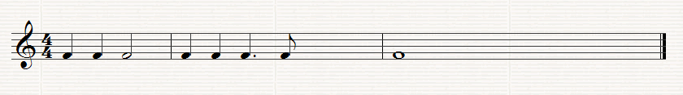

(a) G sharp Melodic minor, ascending, with key-signature and also including any further accidentals that may be necessary

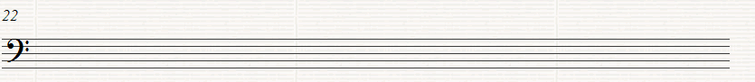
(b) sharp harmonic minor, ascending without using key signature and adding any accidentals that may be necessary

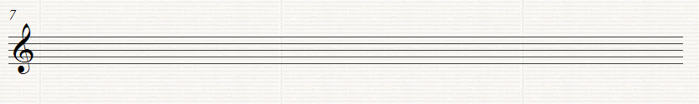

Question 5. (10 Marks)
Write the Key signature and Tonic Triad of each of the following keys.

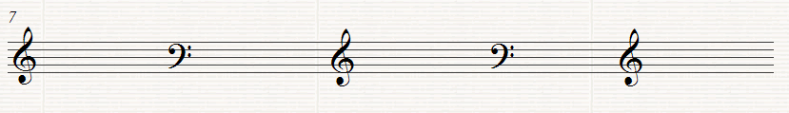

E major F minor F major F# minor D major

Question 6. (10 Marks)

Transpose the following melody down an octave. Use the Bass clef as shown

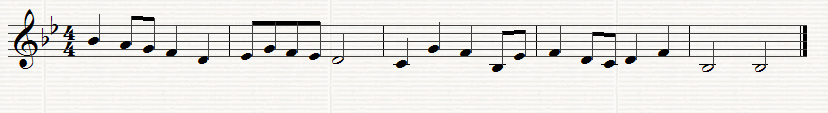
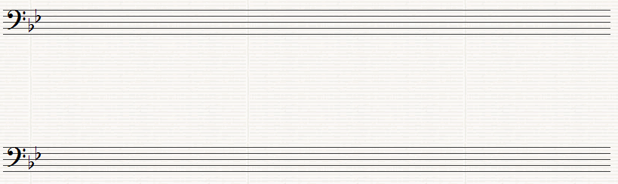

Question 7. (10 Marks)

Above each of the following notes write a higher note to form the named interval. The key is D minor

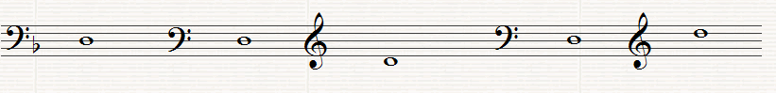

Major 7th Major 2nd Perfect 4th Minor 6th. Minor 3rd

Question 8.
This melody is taken from the St. John Passion by Bach. Study the extract and then answer the questions below.

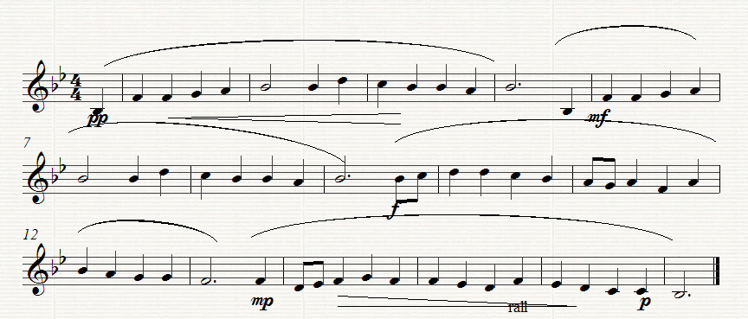

(a) (10 marks)
(I) What is the key of the melody? ____________________________
(ii) What is the relative minor of this key? _________________________
(iii) On which degree of the scale does Bar 14 begin?__________________
(iv) Which note in Bar 10 does not form part of the Tonic triad?______
(v) How often does the rhythm in the first complete Bar recur? ________

(b) (10 Marks)
(I) Underline one on these Italian terms which you think would suit the direction
Alla Marcia, Largo, Presto
(ii) What does rall mean? __________________________________
(iii) What does pp mean? _____________________________________
(iv) Explain what is meant by the symbol under the notes in bars 14 to the end. ________________

(v) Give the letter names of the highest and the lowest notes __________

(c) (10 Marks)
Rewrite the melody from the beginning as far as Bar 9 putting it in 2/4 time. Insert the new time-signature

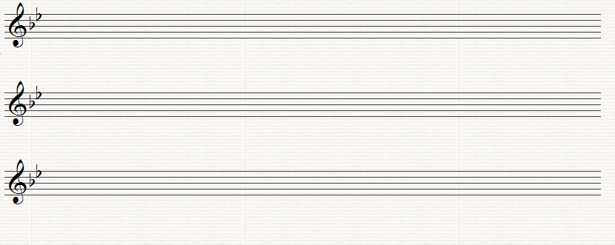

Leinster School of Music and Drama

Theory Examination Paper

Grade 4

Summer 2011

Name:- ________________________________

Total Marks 100

All questions should be attempted.
Please write your answers in this booklet

Duration:- 2 hours

1. (10 Marks) (a) Add the Time signature and missing bar lines to the following extract.
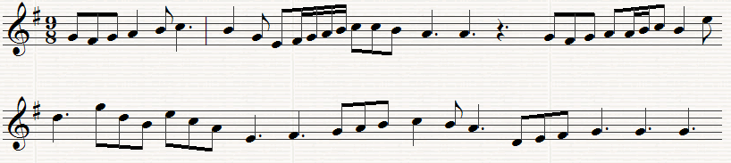

(b) Re-write the following using notes and rests of half the value. Add the new time signature.

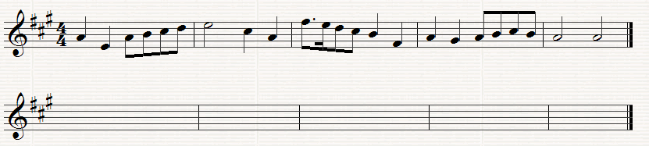

2. (10 Marks) Either:- Write a rhythm on one note, with the time signature and bar lines, to fit these words. Write each syllable under the note or notes to which it is to be sung.
The World’s great age begins anew, the golden years return
The earth doth like a snake renew her winter weeds outworn; (Shelley)
Rhythm ________________________________________________
Words……………………………….....................................................................................
Rhythm___________________________________________________
Words ………………………………...................................................................................
OR
(b) Write a four bar rhythm in 6/8 time. Include the following groups of notes in your rhythm
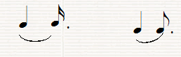
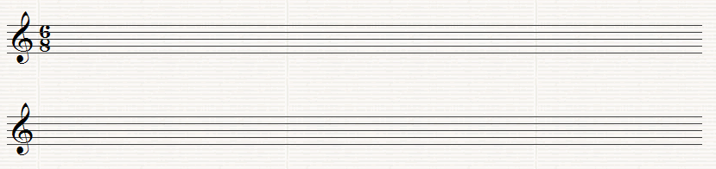
3. (10 Marks)
Name each of the following Notes
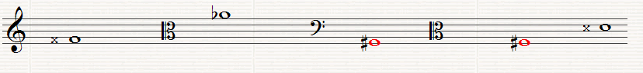
______ ______ ______ ______ ____
4. (10 Marks) Re-write the following notes using the Alto C Clef but keeping the pitch the same.
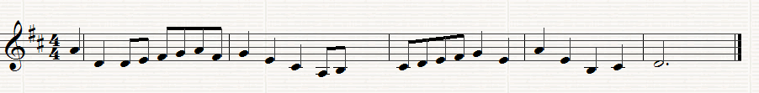
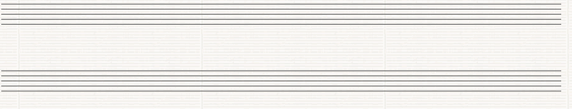
5. (10 Marks) Write the scales named below, using the following rhythm.

(a) Write the key signature of 4 flats and then write the melodic minor scale which has that key signature, ascending, using the given clef. Insert any further necessary accidentals

(b) Write the key signature of 4 sharps and then write the Harmonic minor scale which has that key signature, ascending using the given clef.

(6) (10 Marks) (a) Write the enharmonic equivalent of the following notes as demonstrated in the first example.
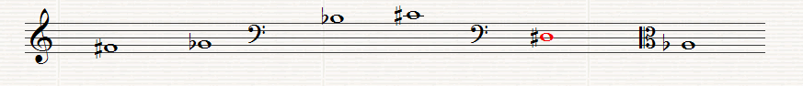
(b) Write a note above each of the given notes to form the named harmonic interval.
Minor 3rd Augmented 4th Major 6th Perfect 5th Major 2nd
7. (10 Marks) (a) Name each of the numbered chords as Tonic, Subdominant or Dominant.
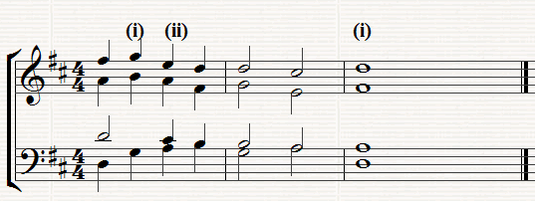
(I) _________ (ii)___________ (iii)_______________

(b) Write the named triads, as shown by the Key-signature

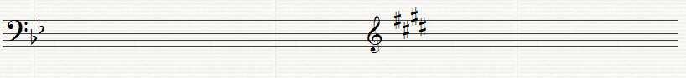
Minor Key Major Key
Subdominant Triad Dominant Triad

8. This is the first violin part from the Nimrod, Variation No. 9 of Elgar’s Enigma Variations. Study it and answer the following questions

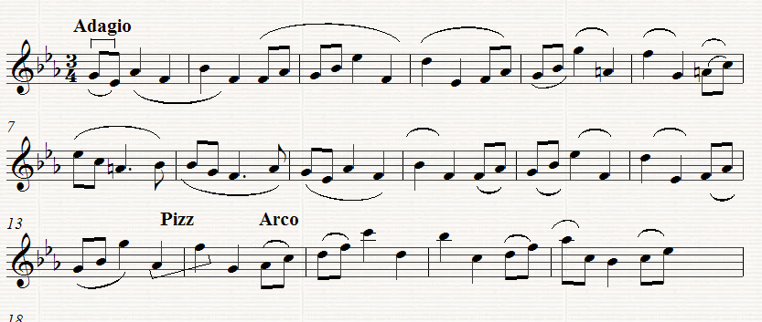
(a) (10 Marks)
Give the meaning of each of the following:-
(i) Adagio ______________________________________________
(ii) in Bar 1________________________________________
(iii) Pizz in Bar 13 __________________________________________
(iv) How many times does the rhythm in Bar 1 recur _________________
(v) Arco in Bar 14 ___________________________________________

(b) (10 Marks)
(i) What is the Interval between the last note in Bar 13 and the first note in Bar 14_________________
(ii) Assuming the Kay is E flat major, what chord in that key is formed by the first three notes in Bar 3 _____________________________
(iii) Assuming that the key is E flat major what is the technical name of the first note in Bar 2 __________________________________________

(iv) Write Bars 1 to 6 down an octave in the Alto Clef.
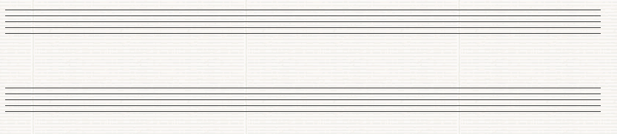
(v) Re-write bars 6 to 9 using notes and rests twice the value.. Insert the new Time Signature.

(c) (10 Marks)
(i) Name the highest sounding Instrument of the Orchestral Woodwind section.___________________________________________________
(ii) Name the four main Brass-wind Instruments ________________
_________________________________________________________
(iii) What are the four open strings on the viola___________________
(iv) Name two Transposing Instruments __________________________
(v) Name two Percussion Instruments _______________________

Leinster School of Music and Drama

Theory Examination Paper

Grade 5

Summer 2011

Name:- ________________________________

Total Marks 100

All questions should be attempted.
Please write your answers in this booklet

Duration:- 2 hours and 30 minutes

Question 1. (10 Marks)
(a) In the following extract several changes of Time signature are needed. Insert the time signatures at the appropriate places.
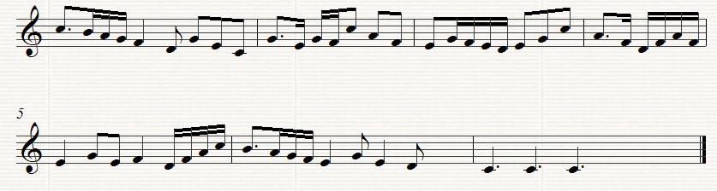
(b) Re-write Bars 4, 5 and of the above melody using the Tenor C Clef
Question 2. (10 Marks)
Re-write the following in open score. Begin as shown..
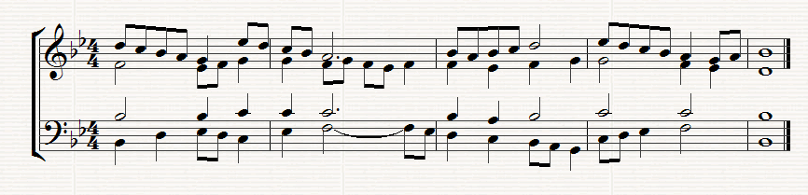
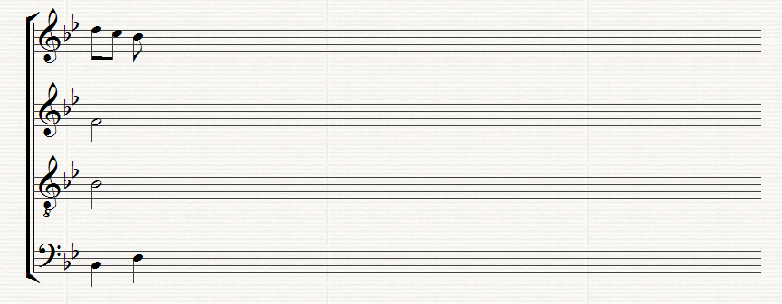Question 3. (10 Marks)
Re write the following melody for the Clarinet in B flat by transposing it up a tone. Insert the appropriate key signature.
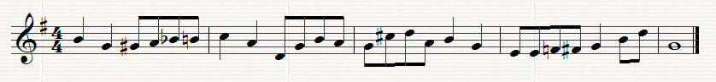

Question 4. (10 Marks)
(a) Write the key signature of 3 sharps after the following C Clef and then the ascending and descending melodic minor scale which has that key signature. Write in minims
- Write the scale of A flat major ascending and descending in the following Clef. Do not use a key signature but insert any accidentals that may be necessary
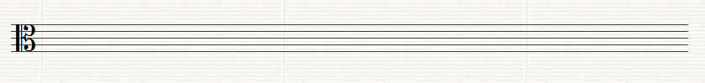
Question 5. (10 Marks)
(a) Write a suitable chord under each of the notes marked *. Use chords I, ii, iv or v or any recognized method of notation
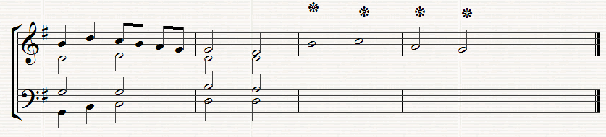
(b) Below the above staves write the progression 6/4,, 5/3 (Chord ic - v) under the two successive chords where this progression occurs

Question 6. (10 Marks)
Write the named Intervals and Triads in the Key of D minor (Harmonic). Do not use a key signature but remember to put in any necessary accidentals which may be necessary.
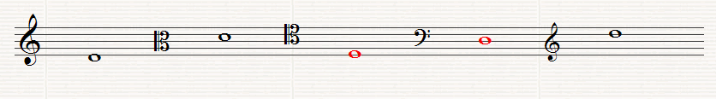
Perfect 5th Minor 3rd Major 7th Tonic Dominant
Triad Triad
Question 7. (10 Marks)
Answer Either A or B
(a) Write a melody for an Instrument of your choice using the given opening. Add marks for Tempo and Expression and any other performance directions which may be appropriate for the instrument chosen. The complete melody should not be more that 8 bars long
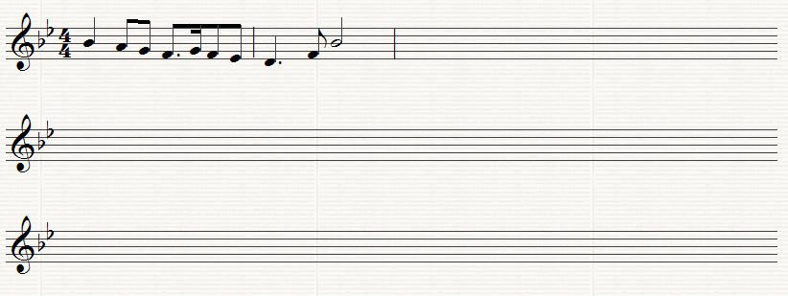
Instrument for which the melody is written ____________________
OR
(b) Compose a melody to suit the following words. Write each syllable under the note or notes to which it is to be sung.
Will no one tell me what she sings? Perhaps the plaintive numbers flow
For old, unhappy, far-off things, and battles long ago
Wordsworth
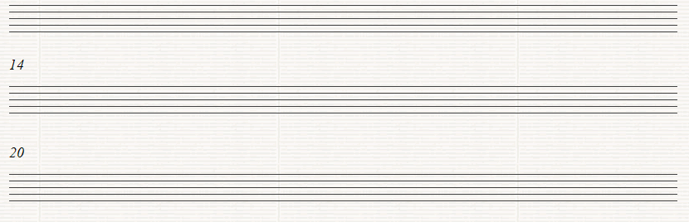

Question 8.
Study the following extract from Scarlatti’s Sonata in A major, K321, L 25 and answer the following questions
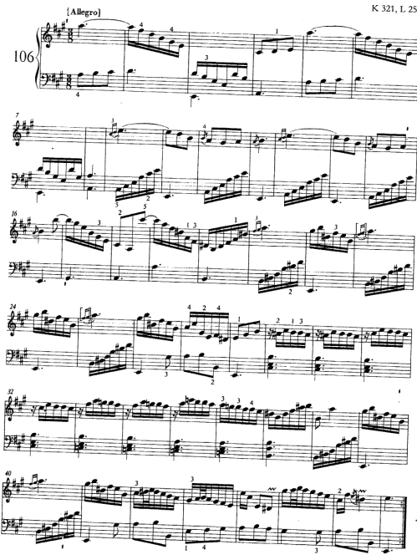

(a) Give the meaning of the following
(i)Allegro__________________________________________________
(ii) in Bar 44 _________________________________________
(iii) in Bar 15______________________________________
(iv) 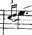 in Bar 9 _______________________________________
(v) Write out the note values of the right hand part in Bar 11

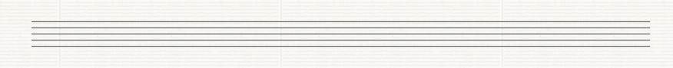

(b) (10 Marks)
(I) Which pair of Brass wind Instruments could play the first four bars in the right hand? _________________________________________________________
(ii) What chord is outlined in Bar 7? _____________________________
(iii) The key changes in Bar 22 to E minor. What relationship does the key of E major have to A major?_________________________________
(iv) What is the Interval between the two Left hand notes in Bar 9?
____________________________________________________
(v) Write the enharmonic equivalent of the notes in the left hand of Bar 21

(c) (10 Marks)
Rewrite the right hand part of Bars 1 to 4 in notes of twice the value. Insert the new time signature

