

Leinster School of Music and Drama

Theory Examination Paper

Preparatory Grade

December 2011

Name:- ________________________________

Total Marks 100

All questions should be attempted.
Please write your answers in this booklet

Duration:- 1 hour

Question 1 (10 Marks)

Write the letter names of each of the following notes in the space provided

_____ _____ _____ _____ _____

Question 2 (10 Marks)

Write the following notes as Minims (Half notes)

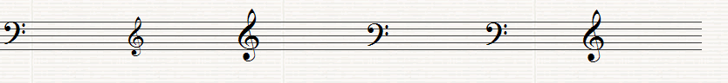
G in a space A in a space E on a line B on a line A on a line D on a line

Question 3 (10 Marks)

Insert the correct Clef before each of these notes to make the letter name fit

G E A F F

Question 4 (20 Marks)

Write the letter name and value time each note below each the following. (i.e. C, 1 beat)

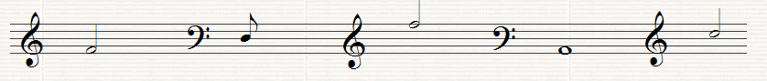

Letter ______ _______ _______ _______ _______

Time _______ ______ _______ _______ _______

Question 5 (10 Marks)

Fill in the missing Time Signatures before each of the following extracts

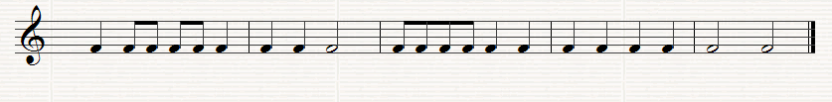

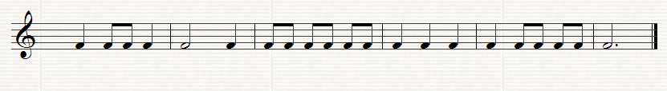

Question 6. (10 Marks)

Put one note only at each Asterix to make the time signature correct

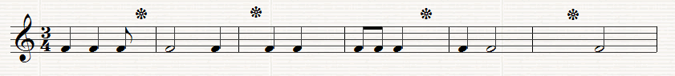

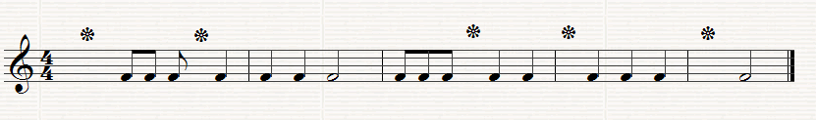

Question 7.
Answer the Questions on the following Piece of Music. All of the answers are found in the extract.

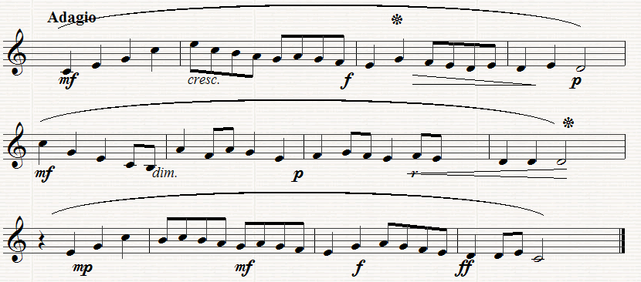

- (10 Marks)

Put in the correct time signature at the start of the extract
How many bars are there in the piece? ___________________________
What type of clef is used? _____________________________________
Which is the loudest bar in the piece? ____________________________
Which is the softest bar in the piece? ____________________________

(b) (10 Marks)
What does f mean? _________________________________________
What does mp mean__________________________________________
What does dim mean ____________________________________
Name the note marked * in Bar 3 _____________________________
What is the value of the note marked * in Bar 8 __________________

( c) (10 Marks)

Copy out the last four bars in the clef, time-signature and any directions given.

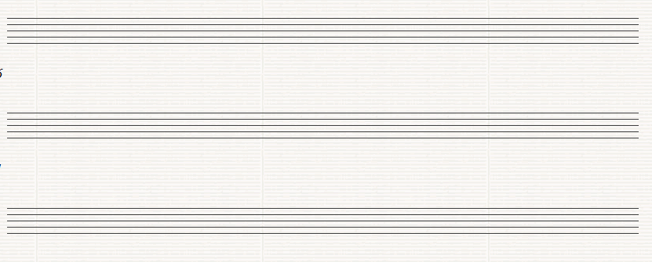

Leinster School of Music and Drama

Theory Examination Paper

Grade 1

December 2011

Name:- ________________________________

Total Marks 100

All questions should be attempted.
Please write your answers in this booklet

Duration:- 1 hour and 30 minutes

Question 1. (10 marks)

(a) Write the letter names of each of the following notes in the space provided

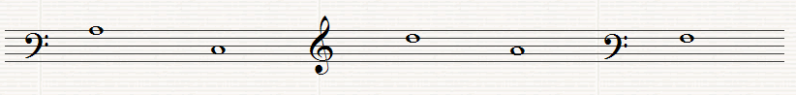
______ ______ ______ ______ ______

(b) write the following notes as Crotchets (Quarter notes)

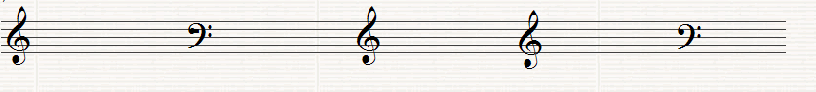

G in a Line A in a Space C in a Space E in a Space D on a line

Question 2. (10 Marks)

Write the letter names (including sharp, flat or natural) and the time name of each of the following notes (i,e. C#, quaver)

Letter _____ _____ ______ _____ _____

Type _____ _____ ______ _____ _____

Question 3. (10 Marks)

(a) Fill in the missing Time Signature before each of the following extracts

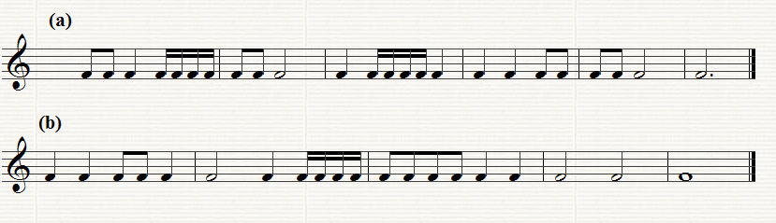

(b) Put one note only at each asterix to make the time-signature correct

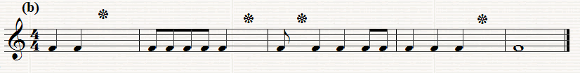

(c) Put one rest only at each asterix to the make the time signature correct

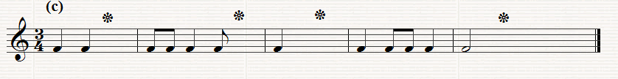

Question 4. (10 Marks)

(a) Re-write this extract grouping the notes correctly according to the time signature

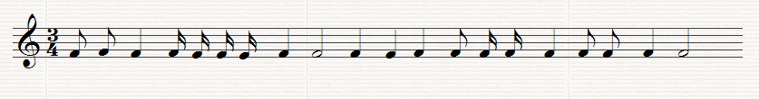
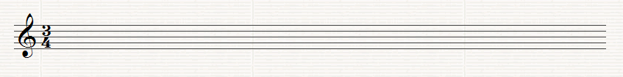

(b) Add the missing Bar lines to the following extract

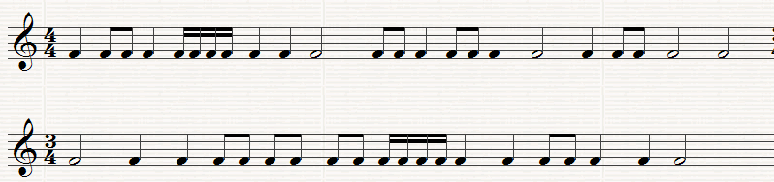
(c) Add two more bars to this opening rhythm

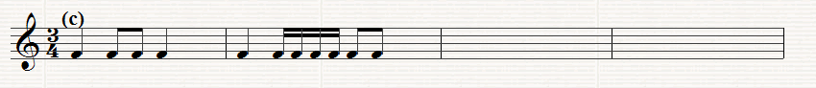

Question5. (10 Marks)

(a) Write the scale of G major, descending with Key-signature, in the given Clef in minims (half notes). Mark the semi-tones with a slur.

(b) Write the scale of D major ascending without key signature, in the given Clef in crotchets (quarter notes). . Mark the semi-tones with a slur

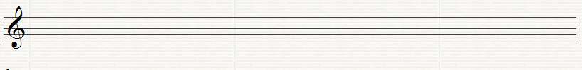

Question 6. (10 Marks)
(a) Write the tonic triads of the following keys using key-signatures

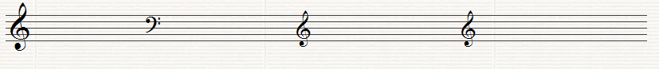

D major C major G major F major

(b) Name the Intervals (by number only) using the bottom note as the tonic (key note)

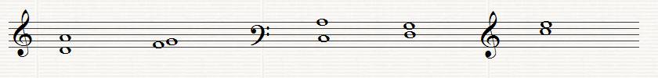
______ ______ ______ _____ _____

Question7. (10 marks)

Name the degrees of the Scale of the following notes, all taken from the Key of G major

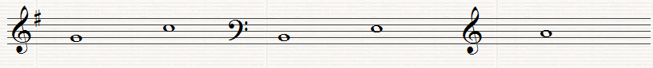

_____ _____ ____ _____ _____

Question 8.

Answer the questions on the following Piece of Music. All answers can be found in the extract

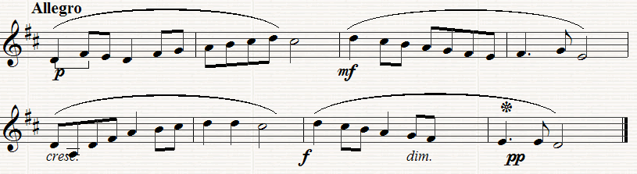

(a) (10 Marks)
What is the Key of the extract?_______________________________
What does Allegro mean?_____________________________________
How many bars are there in the extract? __________________________
What are the long curved lines over the notes known as? _____________
Which degree of the scale is the minim in Bar 6 ____________________

(b) (10 Marks)
Which bar is the loudest? __________________________________
What does pp mean? ________________________________________
What does dim mean?___________________________________
How many beats does the note in Bar 4 marked*get?__________________
What is the interval (by number only) between the first two notes of the extract ______________________________________

(c) (10 Marks)
Copy out the melody from Bar 5 to the end inserting the clef, key-signature, time-signature and any directions needed. Marks will be awarded for neatness and accuracy.
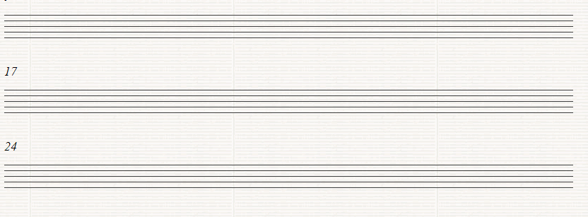

Leinster School of Music and Drama

Theory Examination Paper

Grade 2

December 2011

Name:- ________________________________

Total Marks 100

All questions should be attempted.
Please write your answers in this booklet

Duration:- 1 hour and 30 minute

Question 1. (10 Marks)

(a) Write the letter names of each of the following notes in the space provided

_____ _____ _____ _____ _____

(b) Write the following notes as Minims (Half notes)

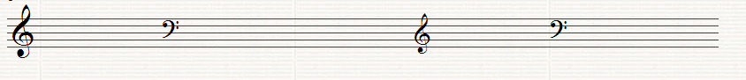
B on a line G in a space F on a line E in a space B in a space

Question 2. (10 Marks)

(a) Write the equivalent rests beside the following notes

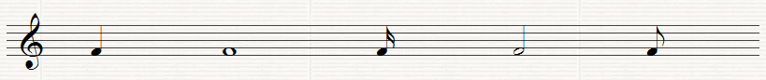

(b) Fill in the missing Time Signature before each of the following extracts

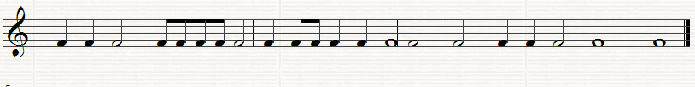

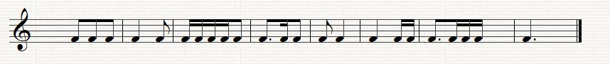

Question3. (10 Marks)
(a) Insert one note only at each asterix to make the time-signature correct

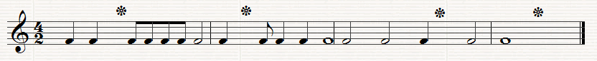

- Put one rest only at each asterix to make the time signature correct
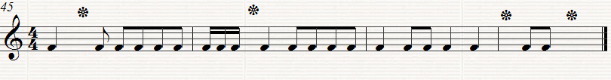

Question 4. (10 Marks)

(a) Re-write this extract grouping the notes correctly according to the time-signature

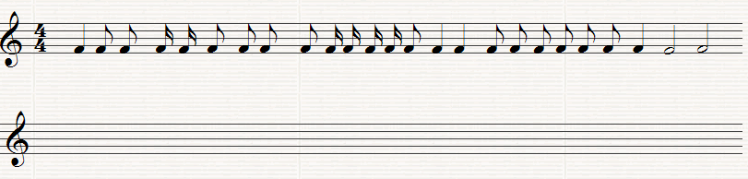

(b) Add the missing bar lines to the following extract

Question 5. (10 Marks)
Use the given opening to make a four-bar rhythm. Use a triplet figure in your answer.

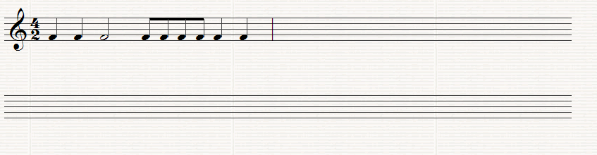

Question 6. (10 Marks)

(a) Write the Scale of E minor (Harmonic or Melodic form) ascending with key-signature. Use crotchets and mark the semi-tones with slurs.

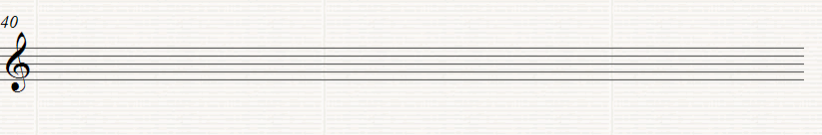

(b) Write the scale of A flat major, ascending without key-signature. Insert any necessary accidentals. Use minims and mark the semi tones with slurs.

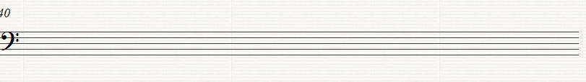

Question 7. (10 Marks)

(a) Write the tonic triads of the following keys without using key-signatures, but adding any necessary accidentals

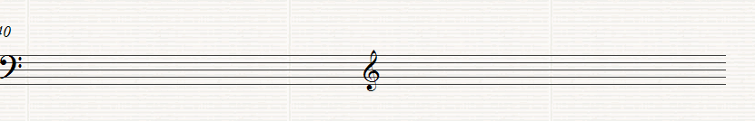
B flat major A minor

(b) Name these Intervals (by number only) using the bottom note as the tonic (key note)

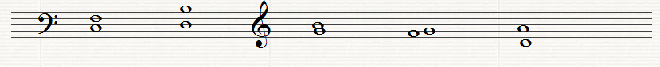
_____ _____ _____ _____ ______

(c) Name the degrees of the scale of the following notes, all taken from the scale of A major

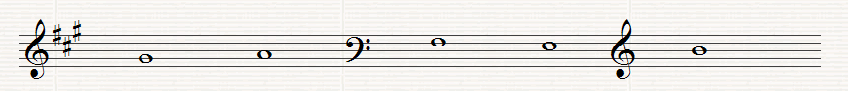
_____ _____ _____ _____ _____

Question 8.

Answer the Questions on the following piece of music. All the answers can be found in the extract.

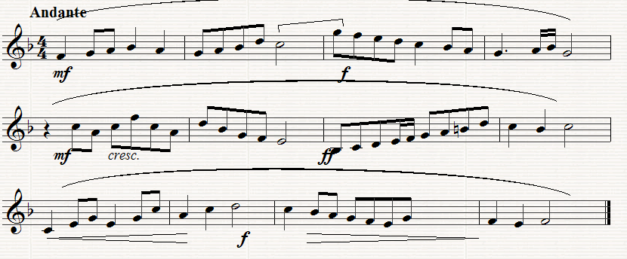

(a) (10 Marks)
(i) What key does the extract begin in? __________________
(ii) What key does the extract change to in Bar 8 ____________
(iii) What is the Interval between the last note in Bar 2 and the first in Bar 3 _______________________________________
(iv) What is the letter name of the highest note ______________
(v) What is the letter name of the lowest note? _______________

(b) (10 Marks)
(i) What does Andant mean?_________________________
(ii) What does cresc mean? ______________________________
(iii) What kind of rest is used in Bar 5 ___________________
(iv) How many phrases are there in the extract? ________________
(v) Describe what directions are given between bars 9 to 12 ____________________________________________________

(c) (10 Marks)
Copy out from Bar 7 to the end of the extract. Insert the Clef, time-signature, key signature and any other directions needed. Marks will be awarded for neatness.

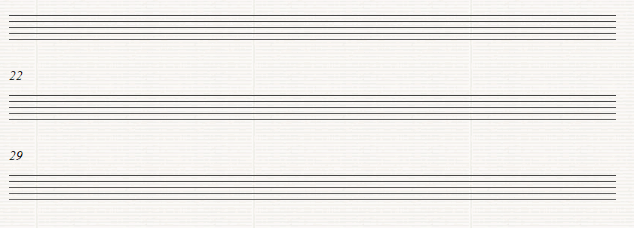

Leinster School of Music and Drama

Theory Examination Paper

Grade 3

December 2011

Name:- ________________________________

Total Marks 100

All questions should be attempted.
Please write your answers in this booklet

Duration:- 2 Hours

Question 1 (10 marks)

Add the missing bar-lines to each of the following extracts which all begin on the first beat of the bar

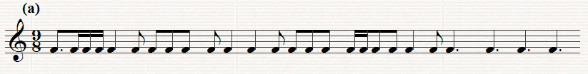

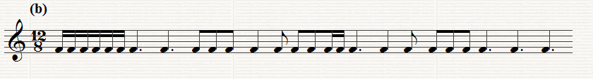

Question 2. (10 Marks)

Write a four bar rhythm in 9/8 time using the given opening which begins on an up beat.

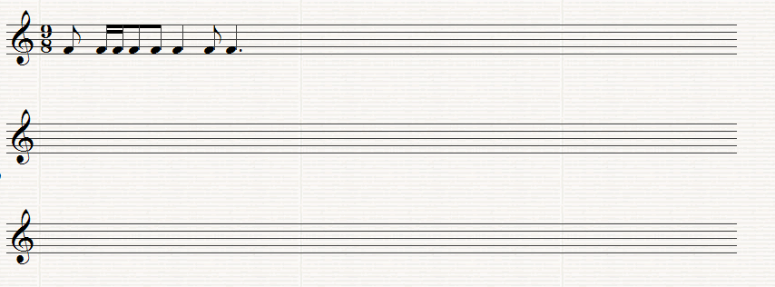

Question 3. (10 Marks)

Rewrite the following with the notes grouped correctly. Add rests to complete the final bar

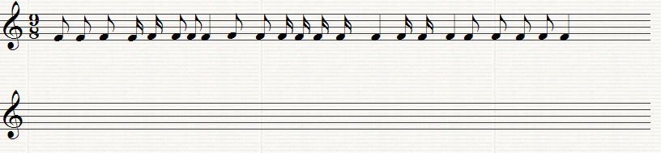

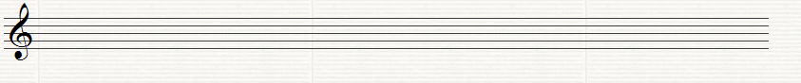

Question 4. (10 Marks)

Write the following scales using the given rhythm

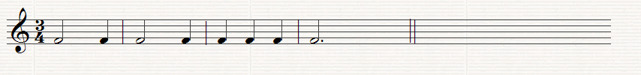

(a) C sharp Melodic minor, ascending, with key-signature and also including any further accidentals that may be necessary

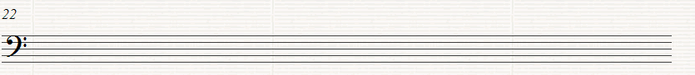

(b) F harmonic minor, ascending without using key signature and adding any accidentals that may be necessary

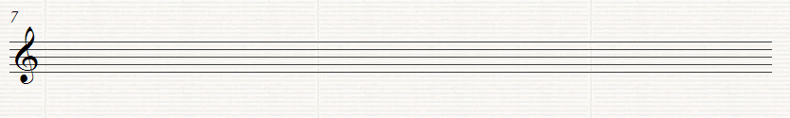

Question 5. (10 Marks)

Write the Key signature and Tonic Triad of each of the following keys.

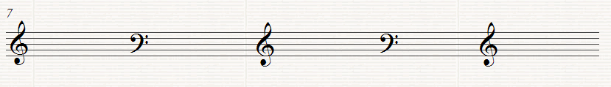

A major F# minor B flat major E minor A flat major

Question 6. (10 Marks)

Transpose the following melody up an octave. Use the Treble clef as shown

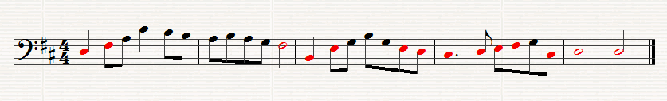

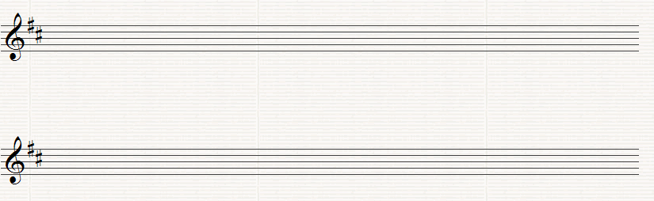

Question 7. (10 Marks)

Above each of the following notes write a higher note to form the named interval. The key is G minor

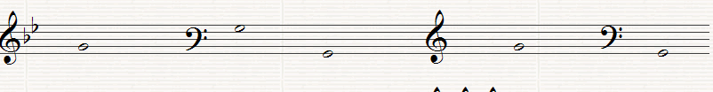
Major 7th Major 2nd Perfect 4th Minor 6th. Minor 3rd

Question 8.
This melody is taken from the St. John Passion by Bach. Study the extract and then answer the questions below.

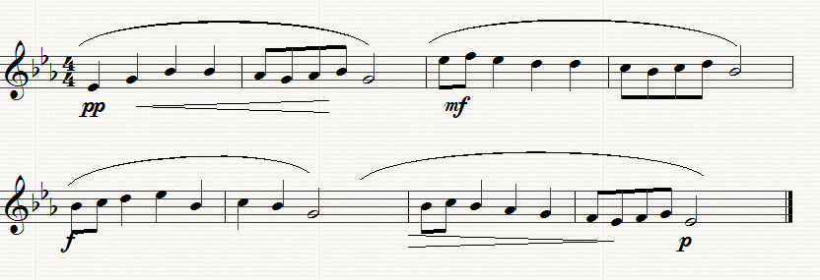

(a) (10 marks)

(I) What is the key of the melody? ____________________________
(ii) What is the relative of this key? _________________________
(iii) On which degree of the scale does Bar 2 begin?__________________
(iv) Which note in Bar 6 does not form part of the Tonic triad?______
(v) How often does the rhythm in Bar 2 recur? _____________________

(b) (10 Marks)

(i) Underline one on these Italian terms which you think would suit the direction
Alla Marcia, Andante, Presto

(ii) What does mean? __________________________________
(iii) What does pp mean? _____________________________________
(iv) Explain what is meant by the symbol under the notes in bars 8 and 9
____________________________________________________________________

(v) Give the letter names of the highest and the lowest notes __________

- (10 Marks)

Rewrite the melody putting it in 2/4 time. Insert the new time-signature

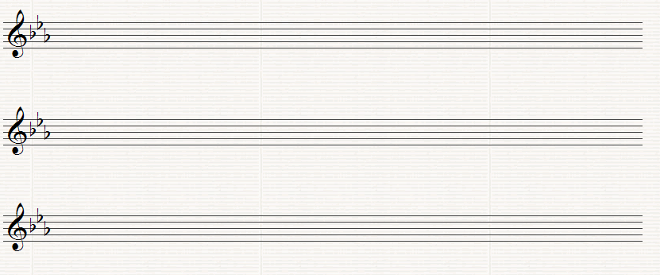

Leinster School of Music and Drama

Theory Examination Paper

Grade 4

December 2011

Name:- ________________________________

Total Marks 100

All questions should be attempted.
Please write your answers in this booklet

Duration:- 2 hours

Question1. (10 Marks)
(a) Add the Time signature and missing bar lines to the following extract.
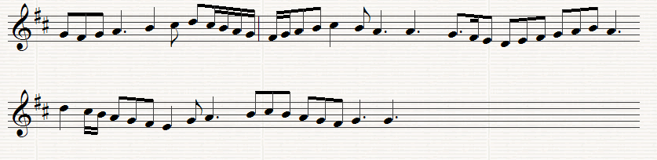

(b) Re-write the following using notes and rests of double the value. Add the new time signature.
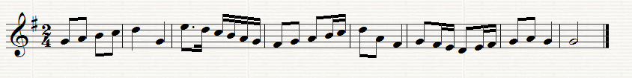
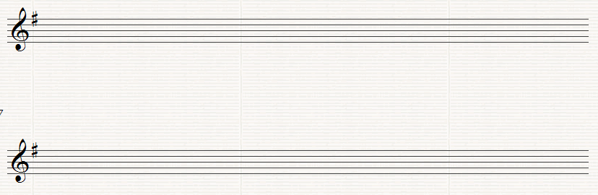

Question 2. (10 Marks)
Either:- Write a rhythm on one note, with the time signature and bar lines, to fit these words. Write each syllable under the note or notes to which it is to be sung.
I traveled among unknown men, in lands beyond the sea,
Nor England! Did I know till then what love I bore to thee
Rhythm _______________________________________________________________
Words……………………………….................................................................
Rhythm________________________________________________________________
Words ………………………………................................................................
OR
(b) Write a four bar rhythm in 9/8 time. Include the following groups of notes in your rhythm
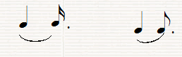
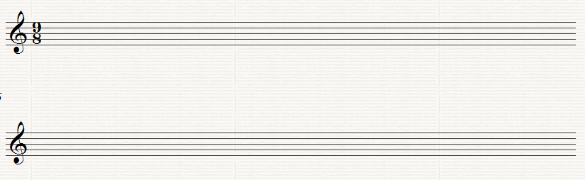
Question 3. (10 Marks)
Name each of the following Notes
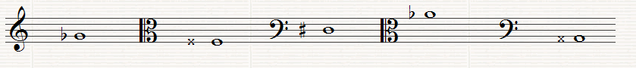
______ ______ ______ ______ _______
Question 4. (10 Marks) Re-write the following using the Alto C Clef but keeping the pitch the same.
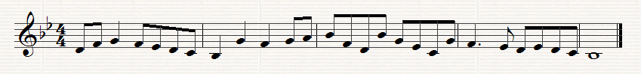
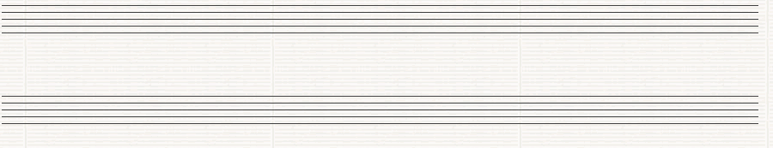

Question 5. (10 Marks)
Write the scales named below, using the following rhythm.

(a) Write the key signature of 4 sharps and then write the minor scale, melodic form which has that key signature, ascending, using the given clef. Insert any further necessary accidentals

(b) Write the key signature of 3 flats and then write the Harmonic minor scale which has that key signature, ascending using the given clef.

Question 6 (10 Marks)
(a) Write the enharmonic equivalent of the following notes.
(b) Write a note above each of the given notes to form the named harmonic interval.
Major 6th Diminished 5th Minor 7th Minor 3rd Aug. 2nd

Question 7. (10 Marks) (a) Name each of the numbered chords as Tonic, Subdominant or Dominant.
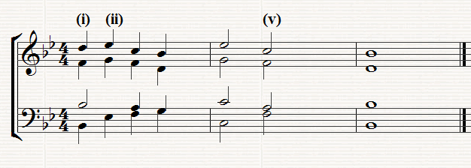
(I) _________ (ii)___________ (iii)_______________
(b) Write the named triads, as shown by the Key-signature

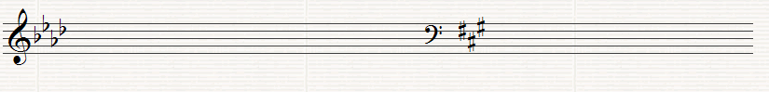
Minor Key Major Key
Subdominant Triad Dominant Triad

Question 8.
This is an extract from Bach’s 1st. study for solo ‘cello Study it and answer the following questions

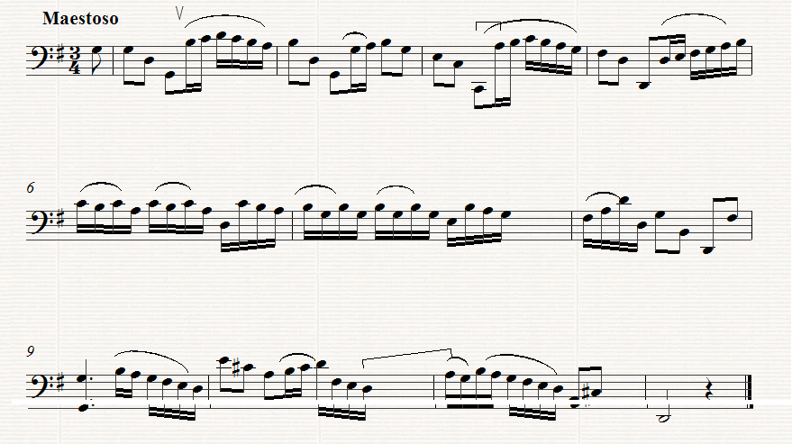
(a) (10 Marks)
Give the meaning of each of the following:-
(i) Maestoso ______________________________________________
(ii) V in Bar 1________________________________________
(iii) in Bar 3 __________________________________________
(iv) How many times does the rhythm in Bar 1 recur ________________
(b) (10 Marks)
(i) What is the Interval between the last note in Bar 10 ad the first note in Bar 11_________________
(ii) Assuming the Kay is G major, what chord in that key is formed by the first four notes in Bar 1 _____________________________
(iii) Assuming that the key is G major what is the technical name of the first note in Bar 3 __________________________________________

(iv) Write Bars 6 to 10 at the same pitch in the Alto Clef.
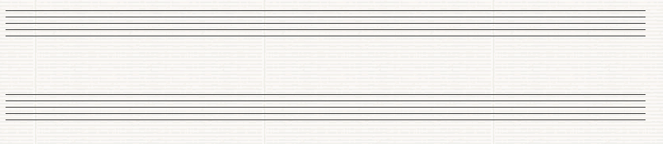
(v) Re-write bars 6 to the end using notes and rests twice the value.. Insert the new Time Signature.

(c) (10 Marks)
(i) Name Four Percussion Instruments:- __________________________________________________________________
(ii) Name the four main Wood-wind Instruments __________________
_________________________________________________________________
(iii) What are the four open strings on the ‘Cello___________________
(iv) Name two Transposing Instruments __________________________
(v) Name two Brass Wind Instruments_____________________________

Leinster School of Music and Drama

Theory Examination Paper

Grade 5

December 2011

Name:- ________________________________

Total Marks 100

All questions should be attempted.
Please write your answers in this booklet

Duration:- 2 hours and 30 minutes

Question 1. (10 Marks)
(a) In the following extract several changes of Time signature are needed. Insert the time signatures at the appropriate places.
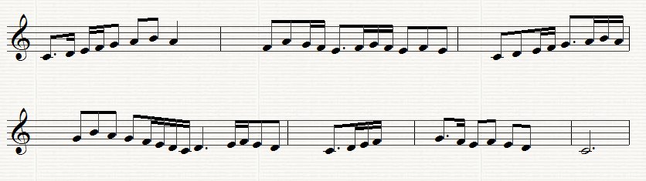
(b) Re-write Bars 4, 5 and of the above melody using the Tenor C Clef
Question 2. (10 Marks)
Re-write the following in open score. Begin as shown..
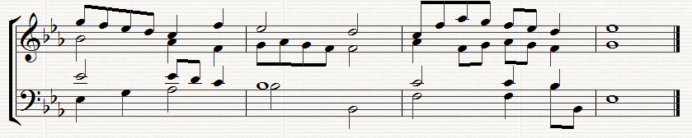

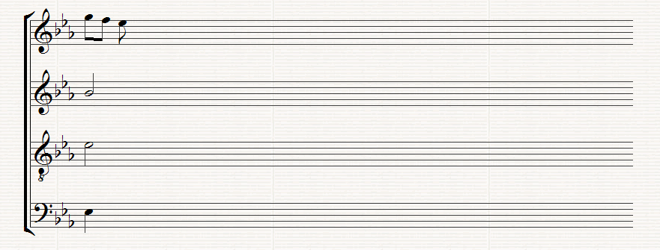
Question 3. (10 Marks)
Re write the following melody for the Clarinet in B flat by transposing it up a tone. Insert the appropriate key signature.

Question 4. (10 Marks)
(a) Write the key signature of 3 flats after the following C Clef and then the ascending and descending melodic minor scale which has that key signature. Write in minims
- Write the scale of E flat major ascending and descending in the following Clef. Do not use a key signature but insert any accidentals that may be necessary
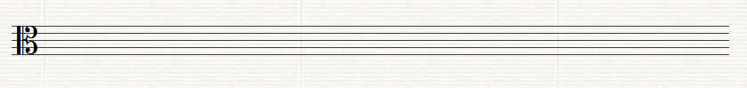
Question 5. (10 Marks)
(a) Write a suitable chord under each of the notes marked *. Use chords I, ii, iv or v or any recognized method of notation
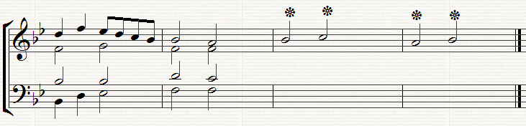
(b) Below the above staves write the progression 6/4,, 5/3 (Chord ic - v) under the two successive chords where this progression occurs
Question 6. (10 Marks)
Write the named Intervals and Triads in the Key of F minor (Harmonic). Do not use a key signature but remember to put in any necessary accidentals which may be necessary.
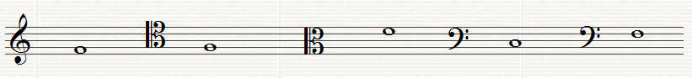
Perfect 5th Minor 3rd Major 2ne Dominant triad Tonic triad

Question 7. (10 Marks)
Answer Either A or B
(a) Write a melody for an Instrument of your choice using the given opening. Add marks for Tempo and Expression and any other performance directions which may be appropriate for the instrument chosen. The complete melody should not be more that 8 bars long
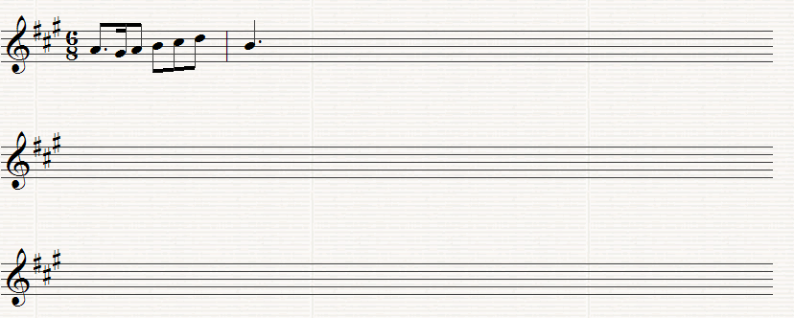
Instrument for which the melody is written ____________________

OR
(b) Compose a melody to suit the following words. Write each syllable under the note or notes to which it is to be sung.
While the cock with lively din scatter the rear of darkness thin,
And to the stack, or the barn door, stoutly struts his dames before
John Milton
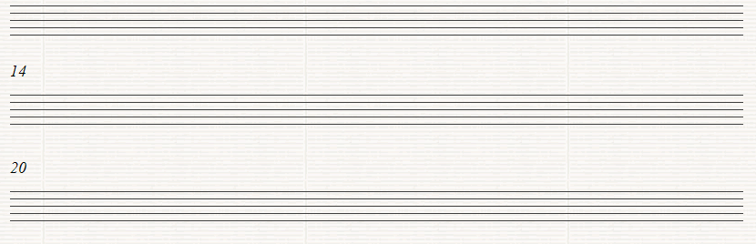

Question 8.
Study the following extract from Bach’s Prelude No. 17 in A flat major, Book 1 answer the following questions
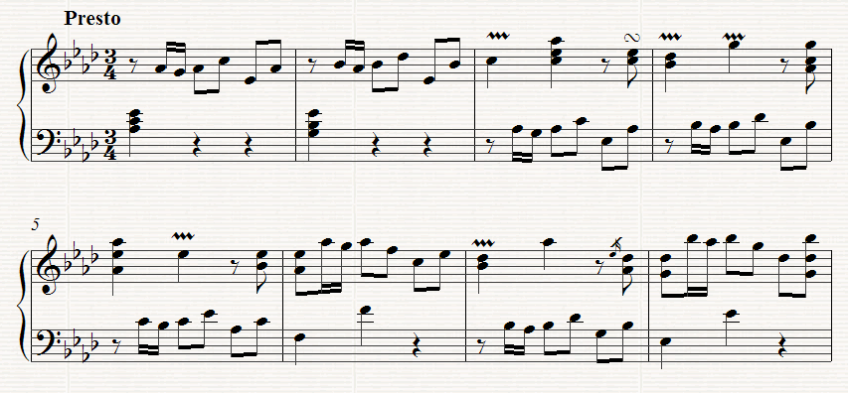
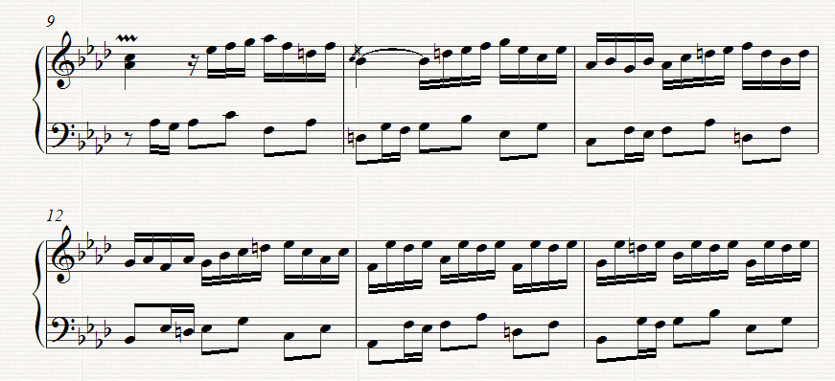
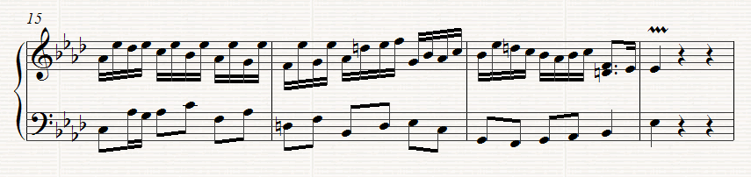

(a) (10 Marks)
Give the meaning of the following
(i) Presto ________________________________________________________
(ii) in Bar 3 _________________________________________
(iii) in Bar 10______________________________________
(iv) in Bar 3 _______________________________________
(v) Write out the note values of the right hand part in Bar 3

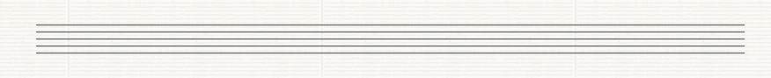

(b) (10 Marks)
(I) Which pair of Wood wind Instruments could play the first four bars in the right hand? _____________________________________________________________________
(ii) What chord is outlined in Bar 2? _____________________________
(iii) The key changes in Bar 18 to E flat major. What relationship does the key of E flat major have to A flat major?_________________________________
(iv) What is the Interval between the two Right hand notes in Bar 13?
____________________________________________________
(v) Write the enharmonic equivalent of the notes in the left hand of Bar 3

(c) (10 Marks)
Rewrite the right hand part of Bars 1 to 4 in notes of twice the value. Insert the new time signature

Leinster School of Music and Drama

Theory Examination Paper

Grade 6

December 2011

Name:- ________________________________

Total Marks 100

All questions should be attempted.
Please write your answers in this booklet

Duration:- 3 hours

Question 1 (15 Marks)

Answer either (a) or (b)

- Indicate suitable chords to accompany the following melody. You may write Roman numerals or any other recognized method of notation below the staves or by writing notes on the staves, but use only one of these methods.

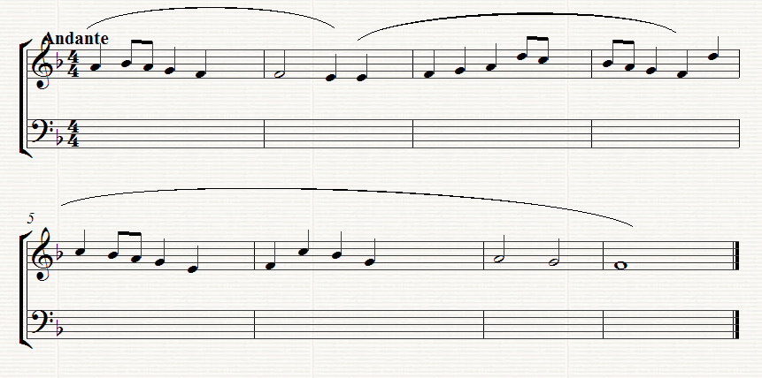
- Complete the figured Bass part in the following extract:-

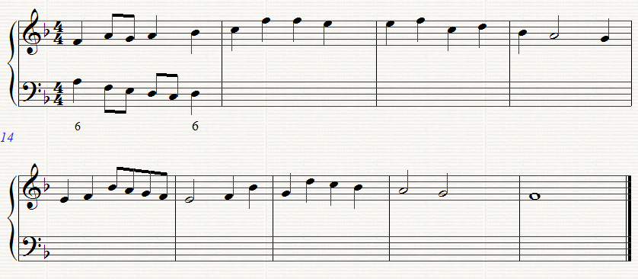

Question 2 (15 Marks)

Write for four Voices (SATB) or keyboard, realize this figured Bass. Assume that all chords are 5/3 unless otherwise shown.

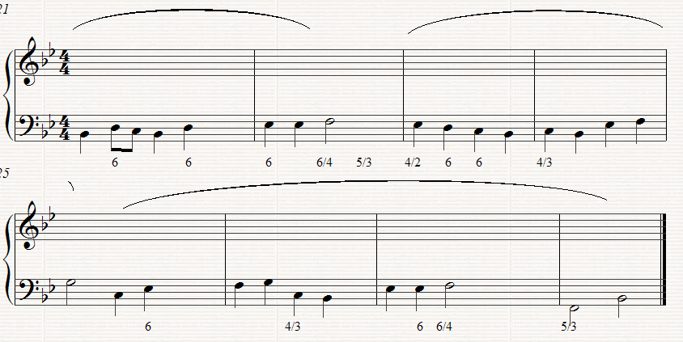

Question 3 (20 Marks)
Answer either (a) or (b)

- Continue this opening to form a melody for unaccompanied clarinet. It should end wit a modulation to the dominant key. The complete melody should be 8 to 10 bars long. Ann performance directions as appropriate.

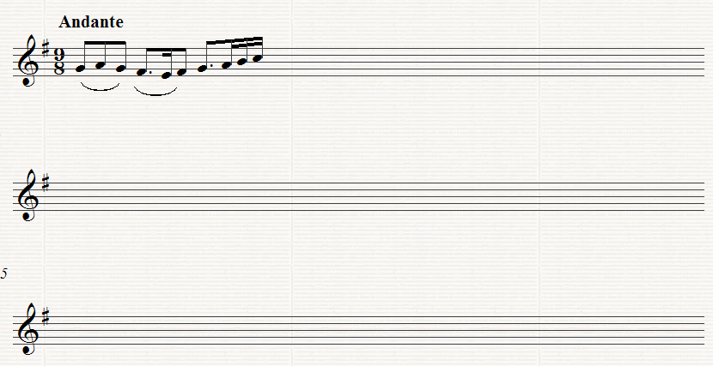

OR

- Continue this opening for unaccompanied Violin to make a complete piece of not less that 8 bars. You should modulate to the key of the dominant. Add performance directions as appropriate.

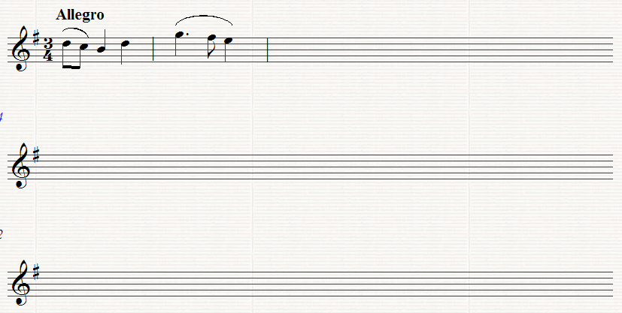

Question 4 (25 Marks)

Study the following extract from Bach’s St. John Passopn with the orchestral part reduced for piano, and then answer the following questions.

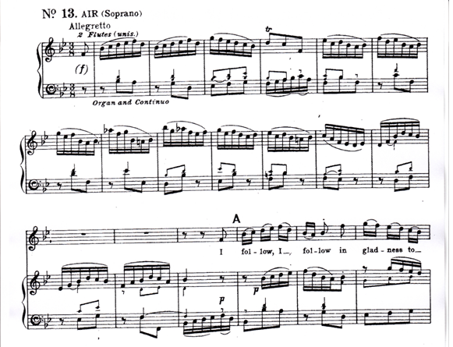

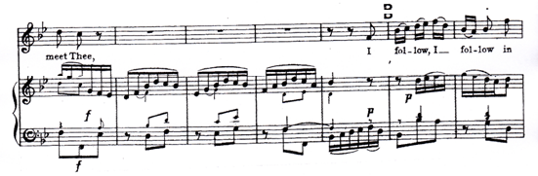

- Mark clearly on the score, using the appropriate capital letters for identification, one example of each of the following

- In the Introduction (bars 1 – 12)

A A Dominant 7th Chord
B A Chord of the Tonic in First Inversion
C A Perfect Cadence
(ii) In the vocal Part,
D A bar outlining the Tonic Chord

(b) Write out the Treble part of Bar 3 as it would be performed

- Write out the first four bars of the vocal part as they would be written for the B flat clarinet

- Draw a circle round the notes in the last two bars which are not part of the Harmony. What is the name given to these notes?

_________________________________________

- Describe the Chord progressions in the four Bars between the two entries of the soloist

________________________________________________________________________________________________________________________________________________________________________________________________________________________________________________________________________________________________________________________________________________________________________

Question 5 (25 Marks)

Study the following Orchestral extract from Beethoven’s 5th Symphony and then answer the following questions:-

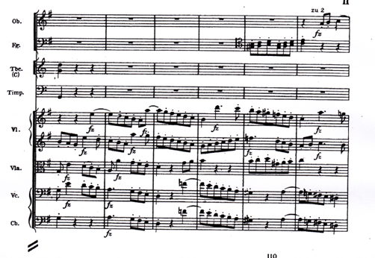
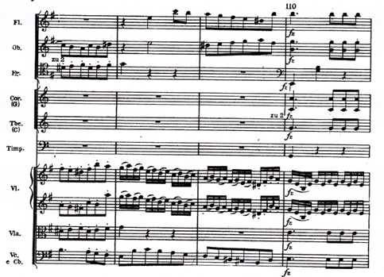

(a)
(i) Explain what u2 for the Flute in the third bar mean? _________
(ii) Name two Brass Instruments which are not included in this extract___________________________________________
(iii)Name one Wood wind and one percussion Instrument which are not included in this extract______________________________________

(iv) Which String Instrument uses mainly staccato here ____________

- Write true or false after each of the following statements:-

(i) The Flutes have an accompanying role only ______________
(ii) the Bassoon plays legato throughout ___________________

- Write out the Bassoon parts up an octave:-

- Mark each of the following clearly on the score, using the appropriate capital letter for identification :-

A A leap of an octave in the Viola Part
B An Interval of a compound Major 3rd between the ‘Cello and the violin
C The interval of a minor 6th. Between 2 Wood wind Instruments

