

Established 1904

The Leinster School of Music & Drama

Theory Examination Paper

Grade 1

December 2010

Name:- ________________________________

Total Marks 100

All questions should be attempted.
Please write your answers in this booklet

Duration:- 1 hour and 30 minutes

Question 1. (10 marks)

(a) Write the letter names of each of the following notes in the space provided

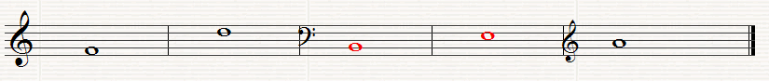

_________ ________ __________ __________ __________

(b) write the following notes as Crotchets (quarter notes)

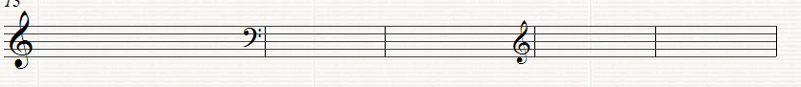

G in a space E in a space A on a line B on a line G on a line

Question 2. (10 Marks)
Write the letter names (including sharp, flat or natural) and the time name of each of the following notes (i,e. C#, quaver)

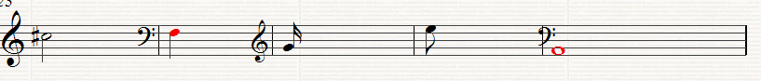

Letter ______ ______ _______ ________ __________

Type________ ______ _______ ________ __________

Question 3. (10 Marks)
(a) Fill in the missing Time Signature before each of the following extracts
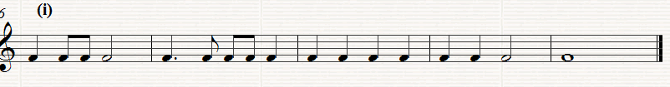
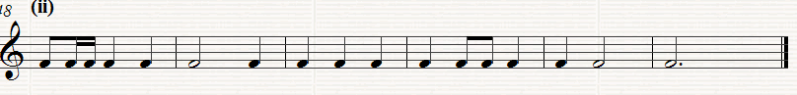

(b) Put one note only at each asterix to make the time-signature correct

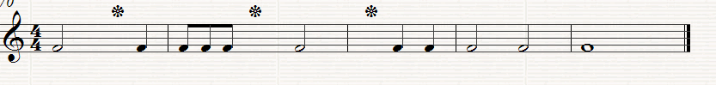

(c) Put one rest only at each asterix to the make the time signature correct

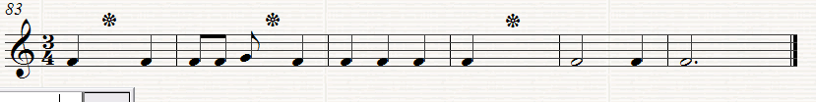

Question 4. (10 Marks)

(a) Re-write this extract grouping the notes correctly according to the time signature
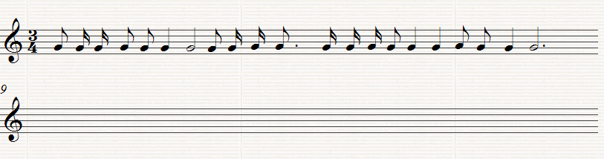

(b) Add the missing Bar lines to the following extract
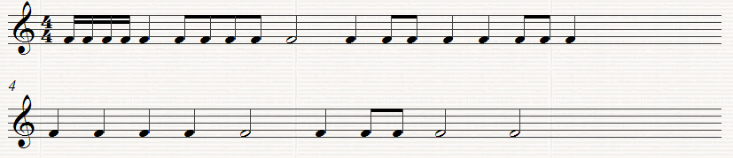
(c) Add two more bars to this opening rhythm

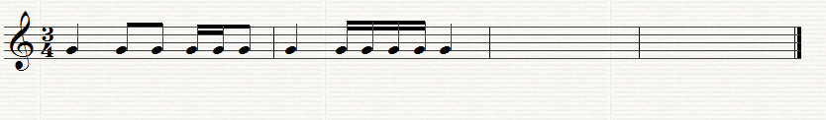

Question5. (10 Marks)
(a) Write the scale of F major, ascending with Key-signature, in the given Clef in crotchets (quarter notes). Mark the semi-tones with a slur.
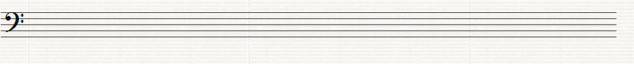

(b) Write the scale of G major descending without key signature in the given Clef in minims (half notes). . Mark the semi-tones with a slur

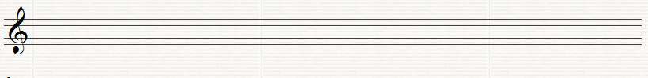

Question 6. (10 Marks)
(a) Write the tonic triads of the following keys using key-signatures

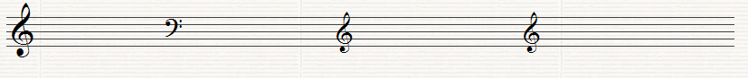

D major C major G major F major

(b) Name the Intervals (by number only) using the bottom note as the tonic (key note)
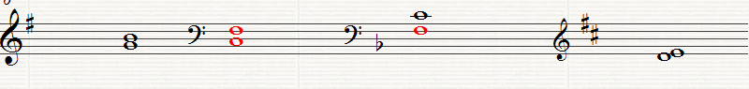
______ ______ ______ _______

Question7. (10 marks)
Name the degrees of the Scale of the following notes, all taken from the Key of G major

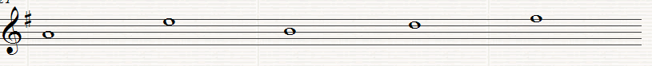
_____ _____ ______ _____ _____

Question 8.
Answer the questions on the following Piece of Music. All answers can be found in the extract

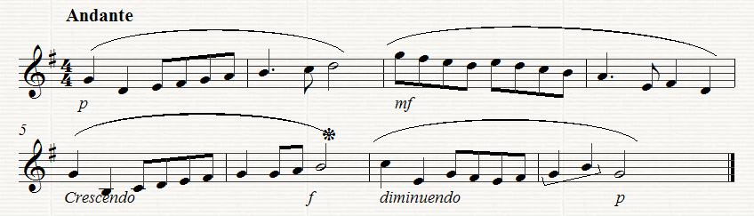

(a) (10 Marks)
What is the Key of the extract?_______________________________
What does Andante mean?_____________________________________
How many bars are there in the extract? __________________________
What are the long curved lines over the notes known as? _____________
Which degree of the scale does Bar 2 begin on? _____________________

(b) (10 Marks)
Which bar is the loudest? __________________________________
What does f mean? ________________________________________
What does diminuendo mean?___________________________________
How many beats does the note in Bar 6marked*get?__________________
What is the interval (by number only) between the first two notes in Bar 8 Marked ¬¬______________________________________________

(c) (10 Marks)
Copy out the melody from Bar 5 to the end inserting the clef, key-signature, time-signature and any directions needed. Marks will be awarded for neatness and accuracy.
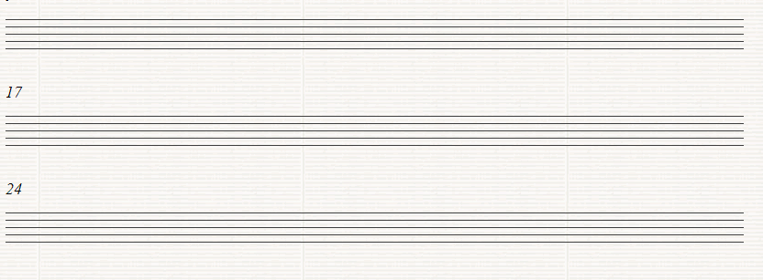

Established 1904

The Leinster School of Music & Drama

Theory Examination Paper

Grade 2

December 2010

Name:- ________________________________

Total Marks 100

All questions should be attempted.
Please write your answers in this booklet

Duration:- 1 hour and 30 minutes

Question 1. (10 Marks)
(a) Write the letter names of each of the following notes in the space provided

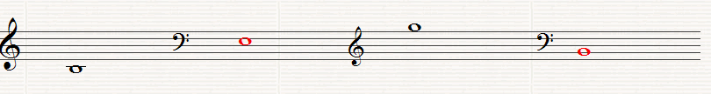
_______ _______ _______ _______

(b) Write the following notes as Crotchets (Quarter notes)

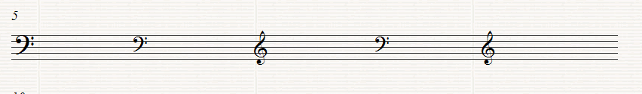
A on a Line D on a line E in a space G in a Space G in a space

Question 2. (10 Marks)
(a) Write the equivalent rests beside the following notes

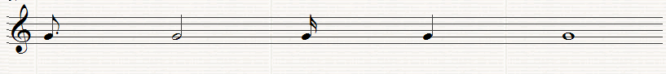

(b) Fill in the missing Time Signature before each of the following extracts

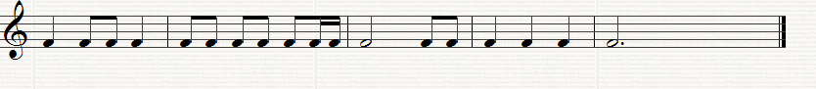

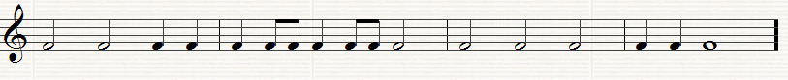

Question3. (10 Marks)
(a) Insert one note only at each asterix to make the time-signature correct

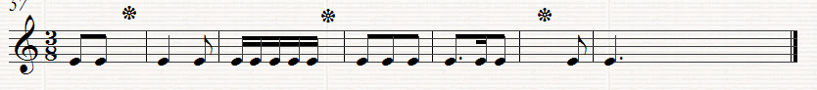

(b) Put one rest only at each asterix to make the time signature correct

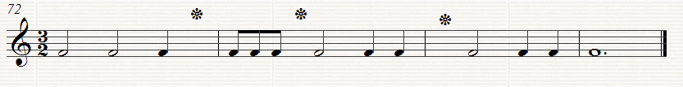

Question 4. (10 Marks)

(a) Re-write this extract grouping the notes correctly according to the time-signature

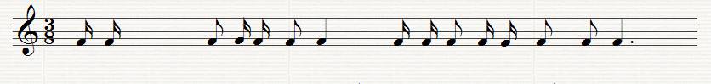

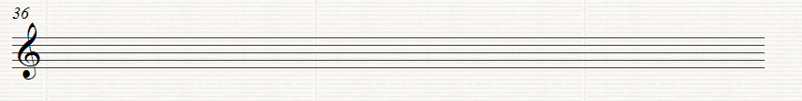

(b) Add the missing bar lines to the following extract

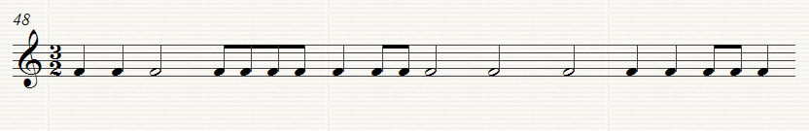

Question 5. (10 Marks)
Use the given opening to make a four-bar rhythm. Use a triplet figure in your answer.

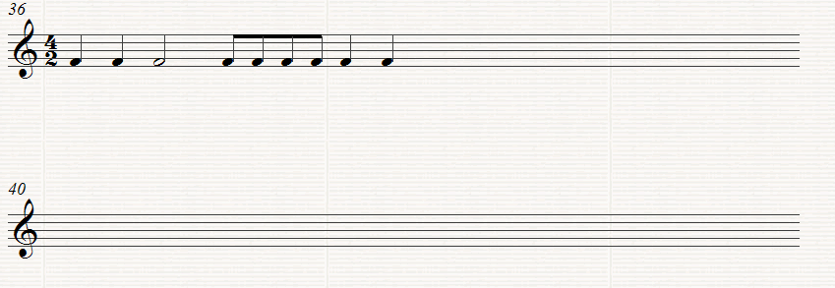

Question 6. (10 Marks)

(a) Write the Scale of E minor (Harmonic or Melodic form) descending without key-signature. Insert any accidentals that may be necessary. Use minims and mark the semi-tones with slurs.

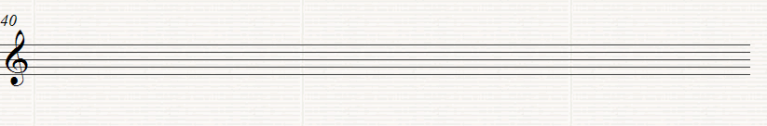

(b) Write the scale of E flat major, ascending with key-signature. Use crotchets and mark the semi tones with slurs.

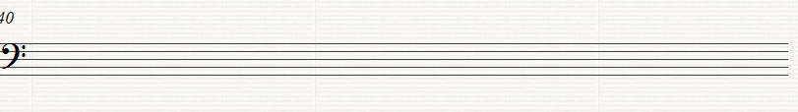

Question 7. (10 Marks)

(a) Write the tonic triads of the following keys using key-signatures.

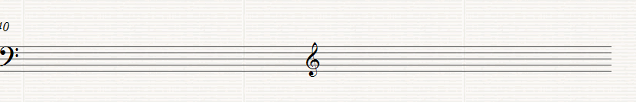

B flat major E minor

(b) Name these Intervals (by number only) using the bottom note as the tonic (key note)

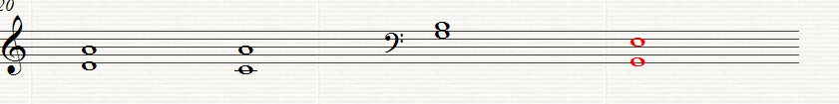

(c) Name the degrees of the scale of the following notes, all taken from the scale of B flat major

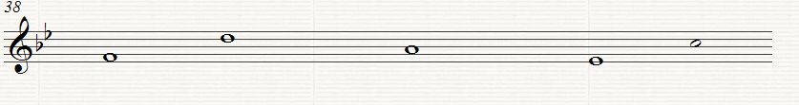
_____ ____ _____ _____ _____

Question 8.

Answer the Questions on the following piece of music. All the answers can be found in the extract.

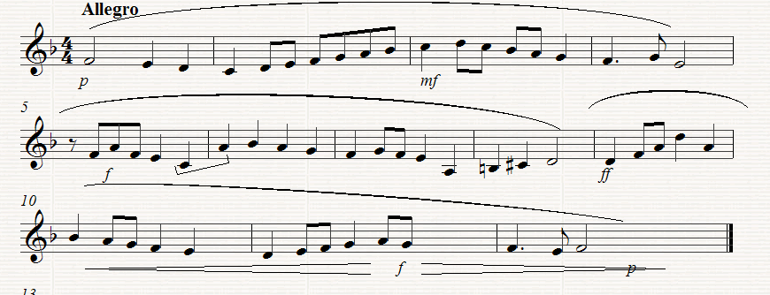

(a) (10 Marks)
(i) What key does the extract begin in? __________________
(ii) What key does the extract change to in Bar 8 ____________
(iii) What is the Interval between the last note in Bar 5 and the first in Bar 6 ____________________________________________
(iv) What is the letter name of the highest note ____________________
(v) What is the letter name of the lowest note? _____________________

(b) (10 Marks)
(i) What does Allegro mean? ______________________________
(ii) What does mf mean? _________________________________
(iii) What kind of rest is used in Bar 5 ___________________
(iv) How many phrases are there in the extract? ________________
(v) Describe what directions are given between bars 10 to 12 _____________________________________________________
(c) (10 Marks)
Copy out from Bar 7 to the end of the extract. Insert the Clef, time-signature, key signature and any other directions needed. Marks will be awarded for neatness.

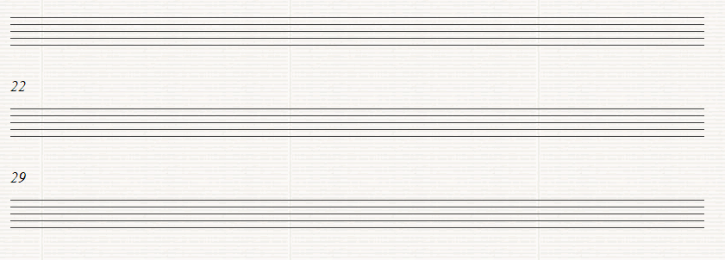

Established 1904

The Leinster School of Music & Drama

Theory Examination Paper

Grade 3

December 2010

Name:- ________________________________

Total Marks 100

All questions should be attempted.
Please write your answers in this booklet

Duration:- 2 Hours

Question 1 (10 marks)

Add the missing bar-lines to each of the following extracts which all begin on the first beat of the bar

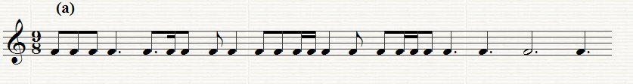

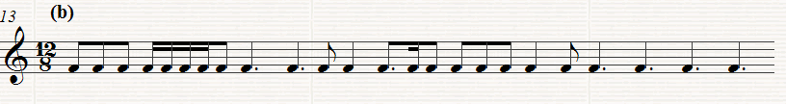

Question 2. (10 Marks)

Write a four bar rhythm in 9/8 time using the given opening which begins on an up beat.

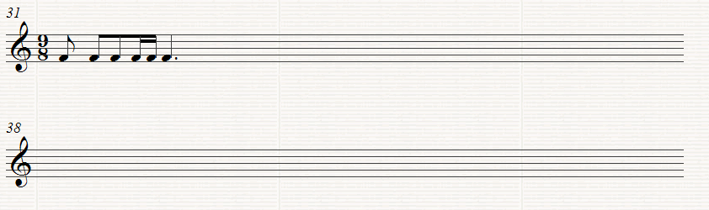

Question 3. (10 Marks)

Rewrite the following with the notes grouped correctly. Add rests to complete the final bar

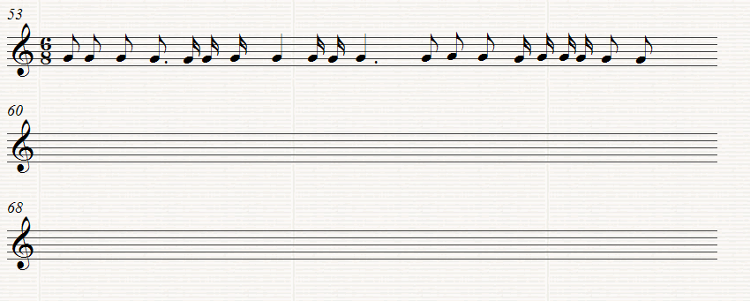

Question 4. (10 Marks)
Write the following scales using the given rhythm

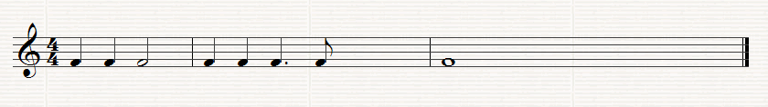

(a) F sharp Melodic minor, ascending, without key-signature but including necessary accidentals.

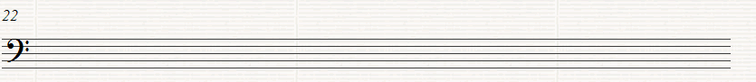

(b) D harmonic minor, ascending using key signature and adding any further accidentals that may be necessary

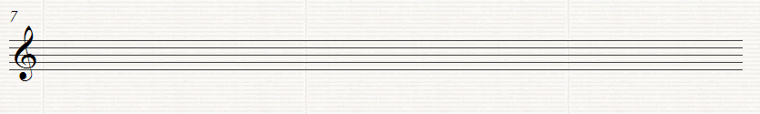

Question 5. (10 Marks)
Write the Key signature and Tonic Triad of each of the following keys.

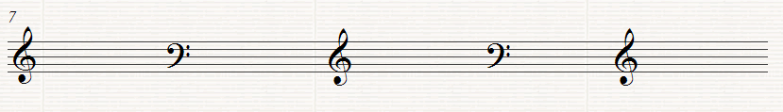

F minor E major C# minor A major E flat major

Question 6. (10 Marks)

Transpose the following melody up an octave. Use the Treble clef as shown

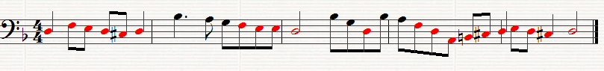
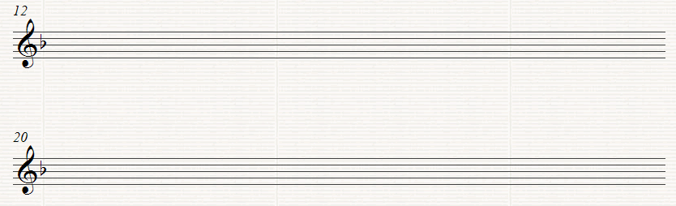

Question 7. (10 Marks)

Above each of the following notes write a higher note to form the named interval. The key is G minor

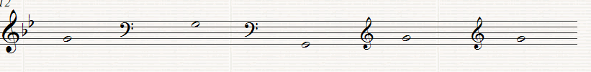 Major 7th Major 2nd Perfect 4th Minor 6th. Minor 3rd

Question 8.
This melody is taken from the St. Matthew Passion by Bach. Study the extract and then answer the questions below.

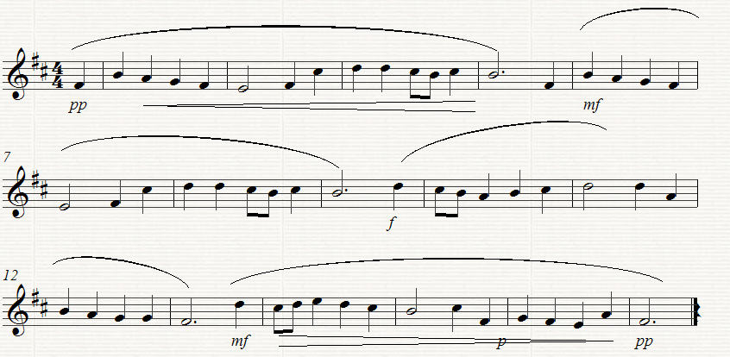

(a) (10 marks)
(I) What is the key of the melody? ____________________________
(ii) What is the relative minor of this key? _________________________
(iii) On which degree of the scale does Bar 13 begin?__________________
(iv) Which note in Bar 7 does not form part of the Dominant triad?______
(v) How often does the rhythm in the first complete Bar recur? ________

(b) (10 Marks)
(I) Underline one on these Italian terms which you think would suit the direction
Alla Marcia, Largo, Presto
(ii) What does rall mean? __________________________________
(iii) What does pp mean? _____________________________________
(iv) Explain what is meant by the symbol under the notes in bars 14 to the end. ________________

(v) Give the letter names of the highest and the lowest notes __________

(c) (10 Marks)
Rewrite the melody from the beginning as far as Bar 9 putting it in 2/4 time. Insert the new time-signature

