

Established 1904

The Leinster School of Music & Drama

Theory Examination Paper

Grade 5

December 2010

Name:- ________________________________

Total Marks 100

All questions should be attempted.
Please write your answers in this booklet

Duration:- 2 hours and 30 minutes
Question 1. (10 Marks)
(a) In the following extract several changes of Time signature are needed. Insert the time signatures at the appropriate places.
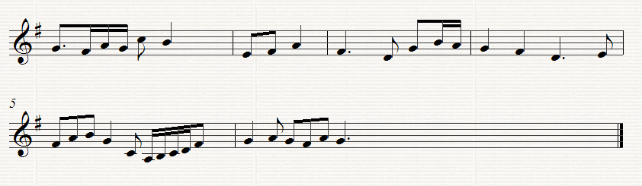
(b) Re-write Bars 4, 5 and of the above melody using the Tenor C Clef
Question 2. (10 Marks)
Re-write the following in open score. Begin as shown..
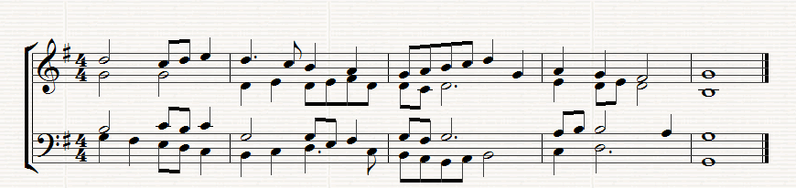
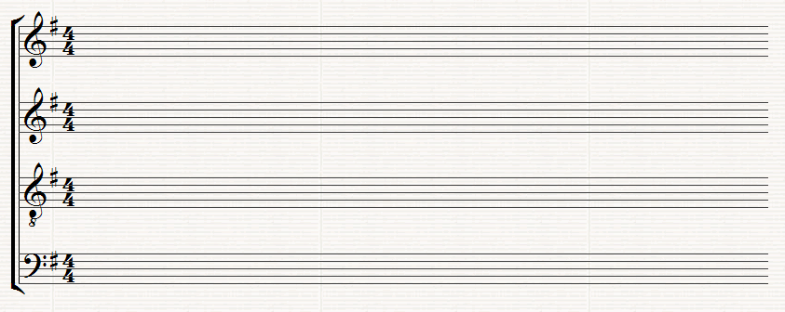Question 3. (10 Marks)
This melody is written for the Clarinet in B flat. Transpose it down a tone so that it will sound at the correct pitch. Insert the appropriate Key signature.
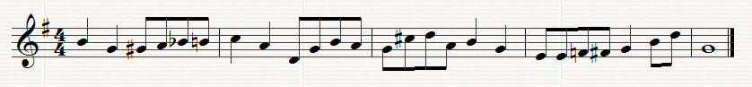

Question 4. (10 Marks)
Write the key signature of 4 sharps after the following C Clef and then the descending and ascending melodic minor scale which has that key signature. Write in minims

Question 5. (10 Marks)
(a) Write a suitable chord under each of the notes marked *. Use chords I, ii, iv or v or any recognized method of notation
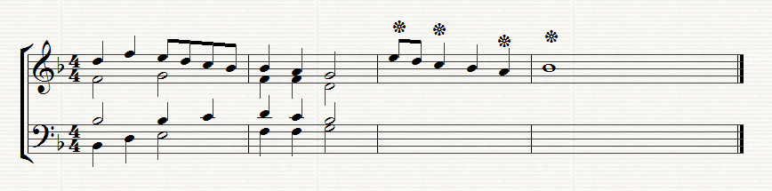
(b) Below the above staves write the progression 6/4,, 5/3 (Chord ic - v) under the two successive chords where this progression occurs

Question 6. (10 Marks)
Write the named Intervals and Triads in the Key of G minor (Harmonic). Do not use a key signature but remember to put in any necessary accidentals which may be necessary.
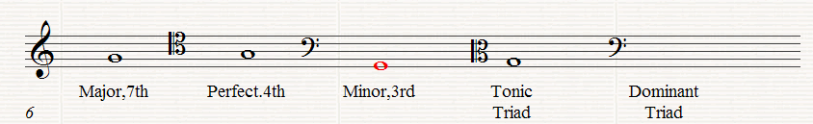

Question 7. (10 Marks)
Answer Either A or B
(a) Write a melody for an Instrument of your choice using the given opening. Add marks for Tempo and Expression and any other performance directions which may be appropriate for the instrument chosen. The complete melody should not be more that 8 bars long
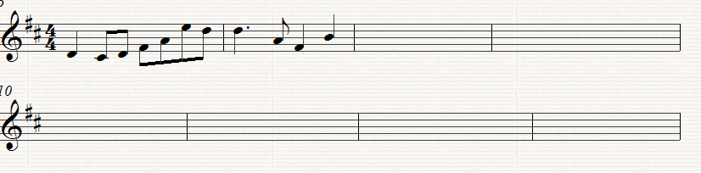

Instrument for which the melody is written _____________________

OR
(b) Compose a melody to suit the following words. Write each syllable under the note or notes to which it is to be sung.
He did not wear his scarlet coat, for blood and wine are red
And blood and wine were on his hands when they found him with the dead
Oscar Wilde
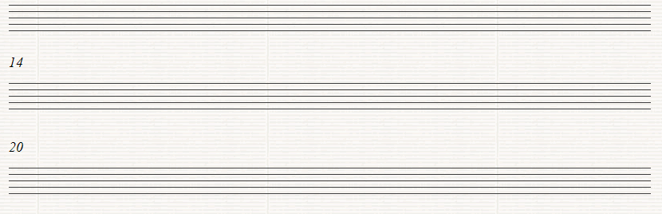

Question 8.
Study the following extract from Scarlatti’s Sonata in C major, K309, L 454 and answer the following questions
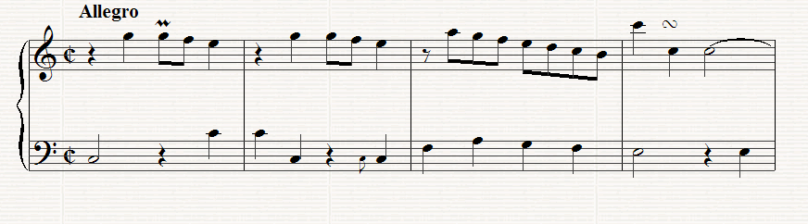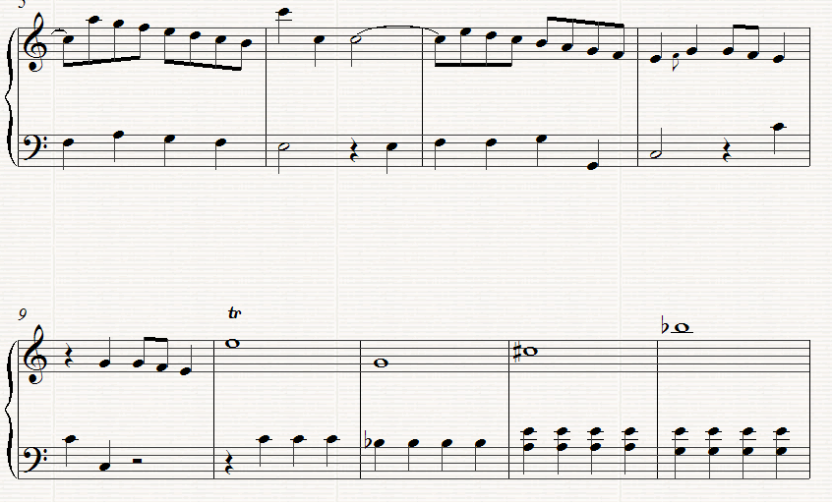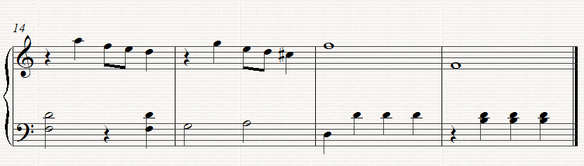

(a) (10 Marks)
Give the meaning of the following
(i)Allegro__________________________________________________
(ii) in Bar 1 __________________________________________
(iii) in Bar 4 _______________________________________
(iv) in Bar 8 _______________________________________
(v) Write out the note values of the right hand part in Bar 10

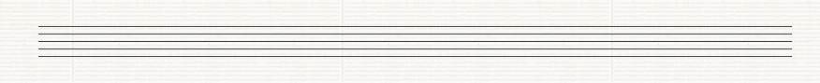

(b) (10 Marks)
(I) Which pair of Brass wind Instruments could play the first four bars in the right hand? _________________________________________________________
(ii) What chord is outlined in Bar 9? _____________________________
(iii) The key changes in Bar 16 to D minor. What relationship does the key of D minor have to C major?_________________________________
(iv) What is the Interval between the two Left hand notes in Bar 13?
____________________________________________________
(v) Write the enharmonic equivalent of the right hand notes in the right hand of Bar 12, 13 and 14

(c) (10 Marks)
Rewrite the right hand part of Bars 1 to 4 in notes of twice the value. Insert the new time signature

Established 1904

The Leinster School of Music & Drama

Theory Examination Paper

Preparatory Grade

December 2010

Name:- ________________________________

Total Marks 100

All questions should be attempted.
Please write your answers in this booklet

Duration:- 1 hour

.
Question 1 (10 Marks)

Write the letter names of each of the following notes in the space provided

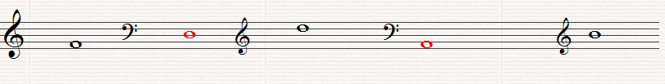 ______ ______ _____ _____ ______

Question 2 (10 Marks)

Write the following notes as Minims (Half notes)

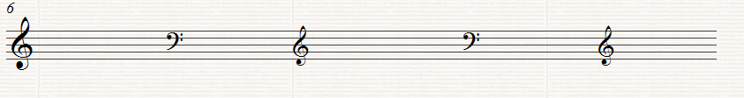
G on a line G in a space A in a space D on a line C in a space

Question 3 (10 Marks)

Put in the correct Clef before each of these notes to make the letter name fit

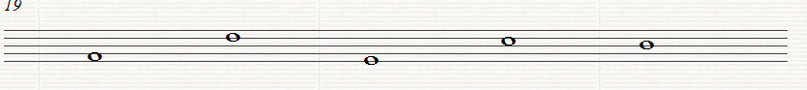
A D G E B

Question 4 (20 Marks)

Write the letter name and time name of each of the following notes (i.e. C, crotchet)

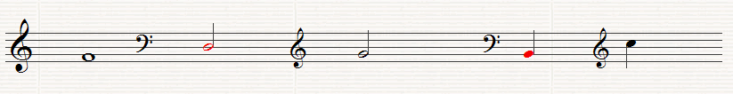

Letter ______ _______ _______ _______ _______
Time _______ ______ _______ _______ _______

Question 5 (10 Marks)

Fill in the missing Time Signatures before each of the following extracts
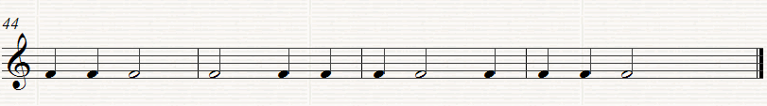
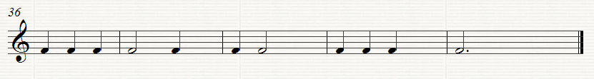

Question 6. (10 Marks)

Put one note only at each Asterix to make the time signature correct

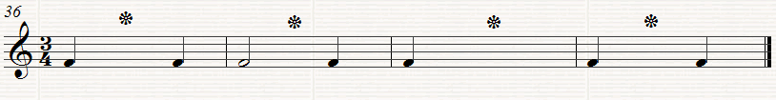
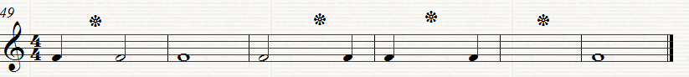

Question 7.
Answer the Questions on the following Piece of Music. All of the answers are found in the extract.

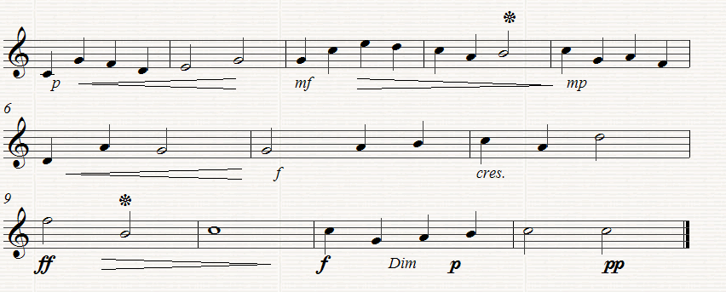

(a) (10 Marks)
Put in the correct time signature at the start of the extract
How many bars are there in the piece? ___________________________
What type of clef is used? _____________________________________
Which is the loudest bar in the piece? ____________________________
Which is the softest bar in the piece? ____________________________

(b) (10 Marks)
What does ff mean? _________________________________________
What does mp mean__________________________________________
What does cres mean ____________________________________
Name the note marked * in Bar 4 _____________________________
What is the value of the note marked * in Bar 9 __________________

(c) (10 Marks)
Copy out the last four bars in the clef, time-signature and any directions given.

