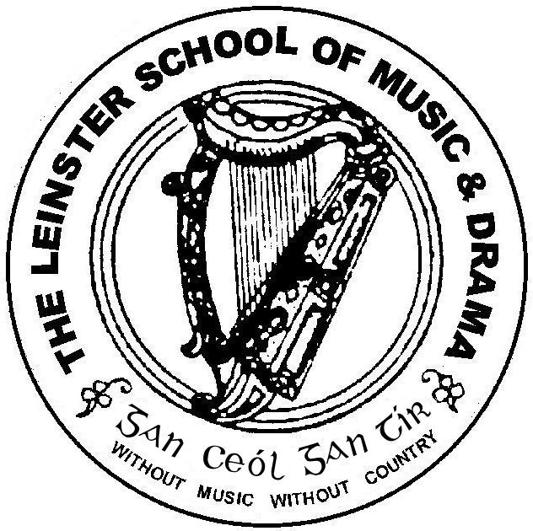

Est 1904

Associate Diploma June 2010

Please number your answers and your pages carefully.

Please answer 5 questions. Questions 1 and 2 are compulsory.*
Time allowed: 3 hours

Question 1*

“Probably the most vexing question about acting is, that of how the actor goes about creating his character” (Bradby). Discuss, with close reference to texts of your choice, your acting process, focusing on the techniques, strategies and exercises you use to capture the essence of a character.

Question 2*

Gordon Luck states that the voice is capable of an infinite combination of tunes and notes, force and rate variations, and tonal changes. Discuss this statement, focusing on your vocal practise, the techniques, and exercises you use to develop your voice for performance.

Question 3
Choose one or two poems that are suitable for choral work. Indicate how you would approach it as choral verse, referring to some strategies and techniques in your discussion.

Question 4
What qualities does the practise of Improvisation promote? Support your answer with reference to a range of stimuli, which aid in the development of these qualities.

Question 5
Compare and contrast two recent theatrical productions, which you have seen, focusing on two or three elements of the performances.

Question 6
Choose an Irish playwright or writer of your choice. Discuss his or her work, comparing and contrasting some of the texts and evaluating their development.

Question 7
“It is the director who makes or breaks the play,” Discuss this view, drawing on your own experience and research concerning the role and function of a director.

Question 8
“However informal, however intimate the situation may be, reading aloud is still a theatrical activity of some sort” ( David Self). Discuss this view, indicating your approach to reading aloud, both narrative and poetic texts.

