The Leinster School of Music & Drama
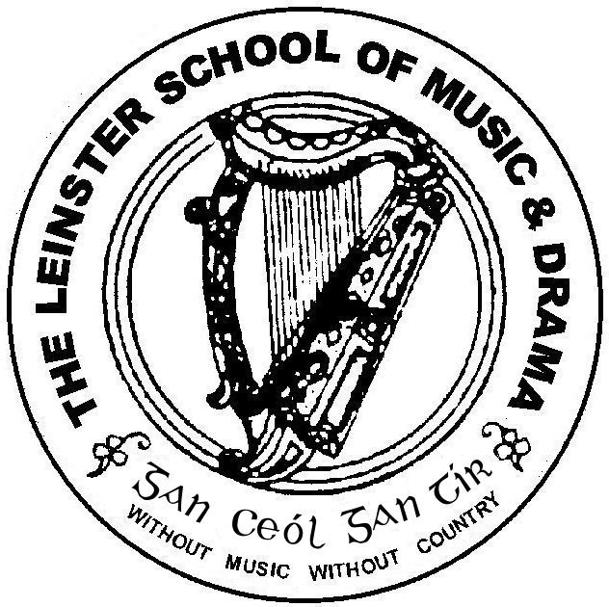

Est. 1904

Associate Diploma December 2011

Please number your answers and your pages carefully.

Please answer 5 questions. Questions 1 and 2 are compulsory.*
Time allowed: 3 hours

Question 1*
Improvisation is used extensively in many Speech and Drama classes. Discuss the benefits, or otherwise, of improvisational strategies, techniques and exercises, outlining your own personal opinion and practice.

Question 2*

Discuss, in detail, the role that breathing, relaxation, resonance and projection play in developing voice production. Illustrate your answer with reference to your own exercises and vocal practise.

Question 3
You have been invited to read some Christmas stories in your local children’s library. Discuss how you would make the most of the skills necessary for reading aloud, in particular, in the context of reading to children.

Question 4

Imagine that you have been cast in a major role in a Shakespearean play. Discuss how you would approach the task of exploring the text, its language, your role and the performance of Shakespearean verse.

Question 5

Give a critique of a production you have seen lately. Focus on two of the following signs of drama: Framing, Actor, Visual, Aural or Text and indicate whether or not you thought the director was successful in making the most of these signs.

Question 6

Discuss the work of an Irish playwright or writer which you find relevant today. Compare and contrast at least two of his works.

Question 7
You have been invited to direct a play for your local Youth Theatre. Discuss your approach as director, strategies and techniques you would adopt, and how you would develop a rapport with this young cast.

Question 8
Choose one or two poems that are suitable for choral work. Indicate how you would approach it as choral verse, referring to some strategies and techniques in your discussion.

