The Leinster School of Music & Drama
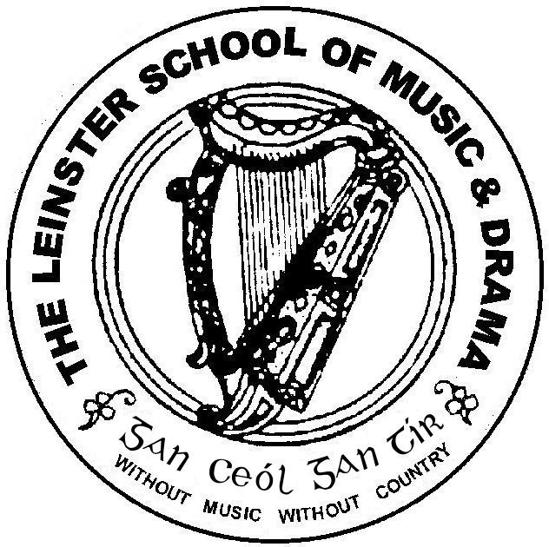

Associate Diploma June 2012

Please number your answers and your pages carefully.

Please answer 5 questions. Questions 1 and 2 are compulsory.*
Time allowed: 3 hours

Question 1*
Compare and contrast two recent theatrical productions, which you have seen, focusing on two or three elements of the performances.

Question 2*

Gordon Luck states that the voice is capable of an infinite combination of tunes and notes, force and rate variations, and tonal changes. Discuss this statement, focusing on your vocal practise, the techniques, and exercises you use to develop your voice for performance.

Question 3
Choose one or two poems that are suitable for choral work. Indicate how you would approach it as choral verse, referring to some strategies and techniques in your discussion.

Question 4

“Probably the most vexing question about acting is, that of how the actor goes about creating his character” (Bradby). Discuss, with close reference to texts of your choice, your acting process, focusing on the techniques, strategies and exercises you use to capture the essence of a character.

Question 5
Mime is used extensively in many Speech and Drama classes. Discuss the benefits, or otherwise of Mime, including techniques and exercises and outlining your own personal opinion and practise.

Question 6
Choose an Irish playwright or writer of your choice. Discuss his or her work, comparing and contrasting some of the texts and evaluating their development.

Question 7
“It is the director who makes or breaks the play,” Discuss this view, drawing on your own experience and research concerning the role and function of a director.

Question 8
Reading aloud and public speaking are necessary skills for all in today’s business world. What advice, techniques, strategies and exercises would you give an inexperienced speaker?

