The Leinster School of Music & Drama
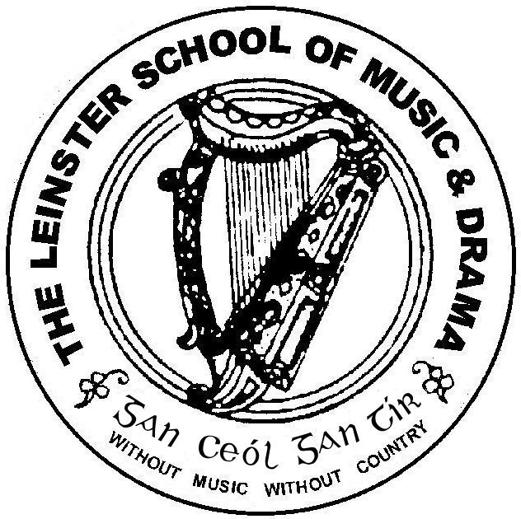

Est. 1904
Associate Diploma June 2014

Please number your answers and your pages carefully.

Please answer 5 questions. Questions 1 and 2 are compulsory.*
Time allowed: 3 hours

Question 1*

“Probably the most vexing question about acting is that of how the actor goes about creating his character” (Bradby). Discuss, with close reference to texts of your choice, your acting process, focusing on the techniques, strategies and exercises you use to capture the essence of a character.

Question 2*

“The ideal speaker combines confident delivery with sensitive interpretation.” Discuss this statement, focusing on the vocal practice, techniques, and exercises necessary to achieve its aim.

Question 3
Choose one or two poems that are suitable for choral work. Indicate how you would approach it as choral verse, referring to some strategies and techniques in your discussion.

Question 4
What qualities does the practice of Mime promote? Discuss these qualities and the journey of Mime in current theatre/drama practice.

Question 5
Compare and contrast two recent theatrical productions, which you have seen, focusing on two or three elements of the performances.

Question 6
Choose an Irish playwright or writer of your choice. Discuss his or her work, focusing on theme, setting, style and language.

Question 7

You have been invited to direct a play for your local Youth Theatre. Discuss your approach as director, strategies and techniques you would adopt, and how you would develop a rapport with this young cast.

Question 8
“However informal, however intimate the situation may be, reading aloud is still a theatrical activity of some sort” ( David Self). Discuss this view, indicating your approach to reading aloud, both narrative and poetic texts.

